SPRING BOOT

**AND**

MICROSERVICE

**BY**

**Kumar4Java**

**SPRING BOOT**

1. **Spring Boot :--**

=>Spring boot is a spring-based framework which is open source and developed by Pivotal Team.

=>Available versions of Spring Boot are a>Spring Boot 1.x.

b>Spring Boot 2.x.

c>Spring Boot 3.x

=>Spring Boot provides **AutoConfiguration** which means reduce Common lines of code in Application which is written by Programmers and handles Jars with version management. (i.e. Providing Configuration code XML/Java and maintaining all jars required for Project **Parent Jars + Child Jars**)

=>Spring Boot is an Abstract Maven project also called as Parent Maven Project (A Project with partial code and jars)

=>Here Programmer will not write configuration code but need to give input data using

a>Properties File (application.properties). b>YAMAL File (application.yml).

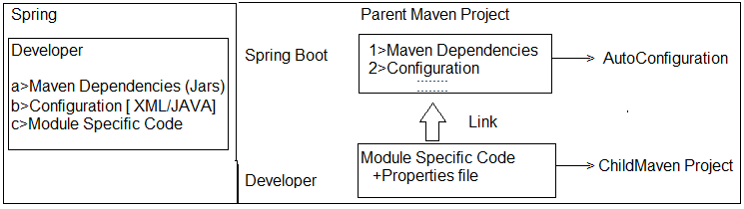

2>Spring Boot:-- a>application.yml:--

server.port: 8082

spring:

datasource:

url: jdbc:mysql://${MYSQL_HOST:localhost}:3306/db

username: user

password: password

jpa:

hibernate.ddl-auto: update

## b>Starter Dependency (which gives config code and Jars):--

## <dependency>

## <groupId>org.springframework.boot</groupId>

## <artifactId>spring-boot-starter-data-jpa</artifactId>

## </dependency>

## <dependency>

## <groupId>org.springframework.boot</groupId>

## <artifactId>spring-boot-starter-web</artifactId>

## </dependency>

=>Spring Boot supports end to end process that is called.

=>Coding => Unit testing => Version control => Build => Deployment => Client Integration.

1. >GIT (github.com) is used to store our code files. It is called as **Central Repository or version Control Tool.**
2. >.Java is converted to .class (Compile) .class + (other files .xml, .html…) converted to .jar/.war finally (build process).
3. >Place .jar/.war in server and start server is called as Deployment.
4. >Spring Boot Application is a service provider app which can be integrated with any UI client like Android, Angular UI, RFID (Swiping Machine), Any 3rd party Apps, Web Apps using Rest and JMS.

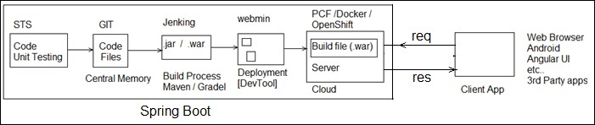

## NOTE:--

a>Spring Boot supports two build tools **Maven** and **Gradle**.

b>Spring Boot supports 3 embedded servers and 3 embedded databases. These are not required to download and install.

**i>Embedded Servers:--** 1>Apache Tomcat (default) 2>JBoos Jetty

3>Undertow

## ii>Embedded DataBase:--

1>H2

2>HSQL DB

3>Apache Derby

## c>Spring Boot supports cloud apps with micro services pattern. [“Both coding and Deployment”].

=>Coding is done using Java and Netflix Tools

=>Deployment can be done on various clouds.

## d>Spring Boot supports basic Operations:--

1>WebMVC and WebServices (Rest).

MVC🡪Model, View , Controller

Important Annotations:

@Controller +@ResponseBody = RestController

@RequestMapping + GET = @GetMapping

2>JDBC and ORM (Hibernate with JPA). 3>Email, Scheduling, JMS, Security.

4>Cache and Connection Pooling.

5>DevTools, Swagger UI, Actuator and Profiles. 6>UI Design using HTML, JSP, Thymeleaf …etc.

## e> Supports Input Data (Key = val) Using (for AutoConfiguration code):--

=>Properties file or YAML files.

* 1. **Spring Boot Application Folder System:--**

=>We can write spring Boot application either using Maven or using Gradle (one of build tool).

=>Our project contains one parent project of spring boot which is internally maven project (hold version of parent).

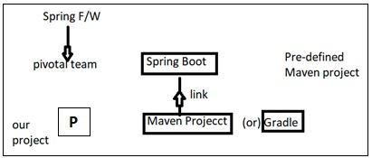

=>Application should contain 3 major and required files. Those are

1. SpringBootStarter class
2. application.properties /application.yml
3. pom.xml/build.gradle
4. **SpringBootStarter class:--** It is a main method class used to start our app. It is entry point in execution. Even for both stand alone and web this file used.
5. **application.properties/application.yml:--** This is input file for Spring boot (Spring container). It holds data in key=value format.

** File name must be “application” or its extended type.

** Even .yml (YAML) file is finally converted to .properties only using SnakeYaml API

** yml is better approach to write length properties code.

1. **pom.xml (or) build.gradle:--** This file holds all information about
   1. Parent boot project version
   2. App properties (JDK version/maven/cloud versions….)
   3. Dependencies (JARS Details)
   4. Plugins (Compiler/WAR…etc)

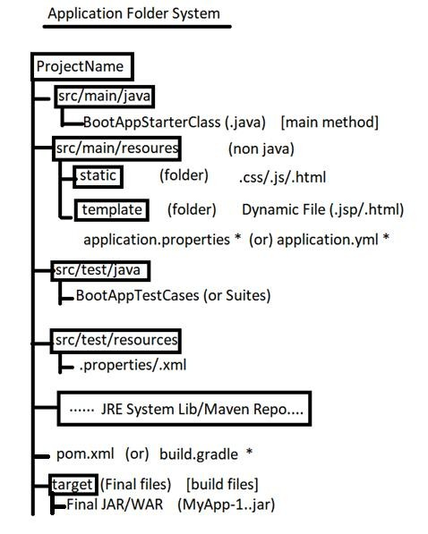

# CHAPTER#1 SPRING BOOT CORE

1. **Spring Boot Runners:--**

=>A Runner is an auto-executable component which is called by container on application startup only once.

=>In simple this concept is used to execute any logic (code) one time when application is started.

## Types of Runners(2):--

* 1. **CommandLineRunner :--** This is legacy runner (old one) which is provided in Spring boot 1.0 version.

=>It has only one abstract method “run(String… args) : void”.

=>It is a Functional Interface (having only one abstract method).

=>Add one **stereotype Annotation** over Implementation class level (Ex:- @Component). So that container can detect the class and create object to it.

## Code Setup:--

#Setup : JDK 1.8 and Eclipse / STS.

## #1. Create Maven Project (simple one):--

=>File=>new=>Maven Project (***Click check box [ v ])=> Create Simple Project

=>Next =>Enter Details (example) Group Id : com.app

ArtifactId : SpringBootRunners Version : 1.0

=>Finish

## #2. Open pom.xml and add parent, Properties, dependencies with plugins:--

Add details in pom.xml (Project Object Model).This file should contain bellow details in same order. It is Automatic Created with project.

1.>Parent Project Details. 2.>Properties (with java version). 3.>Dependencies (jar file details). 4.>Build Plugin.

## pom.xml:--

<project xmlns="<http://maven.apache.org/POM/4.0.0>" xmlns:xsi="<http://www.w3.org/2001/XMLSchema-instance>" xsi:schemaLocation="<http://maven.apache.org/POM/4.0.0> <http://maven.apache.org/xsd/maven-4.0.0.xsd>">

<modelVersion>4.0.0</modelVersion>

<groupId>com.app</groupId>

<artifactId>SpringBootRunner</artifactId>

<version>1.0</version>

<!-- a. Parent Project details -->

<parent>

<groupId>org.springframework.boot</groupId>

<artifactId>spring-boot-starter-parent</artifactId>

<version>2.1.2.RELEASE</version>

</parent>

<!--b. Versions/properties -->

<properties>

<java.version>1.8</java.version>

</properties>

<!-- c. dependencies/jars -->

<dependencies>

<dependency>

<groupId>org.springframework.boot</groupId>

<artifactId>spring-boot-starter</artifactId>

</dependency>

</dependencies>

<!-- d. build plugins -->

<build>

<plugins>

<plugin>

<groupId>org.springframework.boot</groupId>

<artifactId>spring-boot-maven-plugin</artifactId>

</plugin>

</plugins>

</build>

</project>

## #3. Create Properties file under src/main/resources folder:--

=>Right click on “src/main/resources”=>new =>other=>Search and choose “File”

=>next=>Enter name Ex:- application.properties => Finish

## #4. Write Spring Boot starter class under src/main/java folder:--

=>Right click on “src/main/java”> new => class => Enter details, like: Package Name : com.app

Name : MyAppStarter > Finish

## #5. Create one or more Runner classes under src/main/java folder with package “com.app”:--

**#1. Folder Structure of CommandLineRunner & ApplicationRunner with Ordered interface implementations:-**

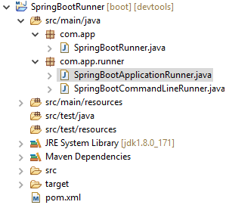

Code:--

## 1>SpringBootRunner.java (Spring Boot Starter class):-- package com.app;

**import** org.springframework.boot.SpringApplication;

**import** org.springframework.boot.autoconfigure.SpringBootApplication;

@SpringBootApplication

**public class** SpringBootRunner {

**public static void** main(String[] args) { SpringApplication.*run*(SpringBootRunner.**class**, args); System.***out***.println("Hello Uday");

}

}

**#Runner #1: SpringBootCommandLineRunner.java package** com.app.runner;

**import** org.springframework.boot.CommandLineRunner;

**import** org.springframework.core.Ordered;

**import** org.springframework.stereotype.Component;

/*CommandLineRunner with Ordered implementations Manual Approach*/ @Component

**public class** SpringBootCommandLineRunner **implements** CommandLineRunner, Ordered {

@Override

**public void** run(String... args) **throws** Exception { System.***out***.println("Hii CommandLine Runner");

}

@Override

**public int** getOrder() {

**return** 50;

}

}

## #Runner #2: SpringBootApplicationRunner.java

package com.app.runner;

import org.springframework.boot.ApplicationArguments; import org.springframework.boot.ApplicationRunner;

import org.springframework.context.annotation.Configuration; import org.springframework.core.annotation.Order;

/*ApplicationRunner with Ordered implications with Annotations*/ @Configuration

@Order(50)

public class SpringBootApplicationRunner implements ApplicationRunner { @Override

public void run(ApplicationArguments args) throws Exception { System.out.println("Hello Application Runner");

}

}

## Output:--

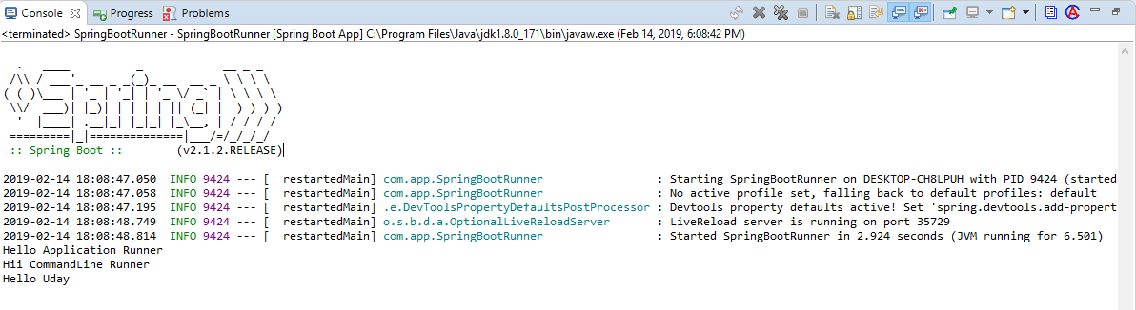

**NOTE:--**

a>Boot Application can have multiple runners Ex:-- EmailRunner, JmsRunner, SecurityRunner, CloudEnvRunner, DevOpsRunner, DatabaseRunner etc… b>Boot provides default execution order.

=>To specify programmer defined order use i>Interface : Ordered or else ii>Annotation : @Order

=>If we are configures both Runner but not implements Ordered then by default

**Annotation based Configuration** will be executed first.

## Input Data to Runners using (CommandLineArguments):--

Programmer can pass one time setup data using Command Line Arguments, in two formats.

a>Option Arguments b>NonOption Arguments

Syntax : --key =val [Option Arguments] Ex:-- --db=MySQL --db=Oracle

--env=prod --server.port=9876 etc…

Syntax : data [NonOption Argument]

Test clean package execute rollnone etc…

**>Data is converted into String[ ] (String…) [var-args] and send to Runner class.

**>Read data based on index or all.

## #2. Folder Structure of Reading Input Data Using CommandLine Arguments:--

**1>Starter class (MyRunner.java):--**

package com.app;

import org.springframework.boot.SpringApplication;

import org.springframework.boot.autoconfigure.SpringBootApplication;

@SpringBootApplication public class MyRunner {

public static void main(String[] args) { SpringApplication.run(MyRunner.class, args); System.out.println("Starter class Called");

}

}

**2>Runner #1 MyInputRunner.java:-- package** com.app.runner;

**import** org.springframework.boot.CommandLineRunner;

**import** org.springframework.stereotype.Component;

@Component

public class MyInputRunner implements CommandLineRunner { public void run (String… args) throws Exception {

System.***out***.println("Hello CommandLineRunner"); System.out.println(args[1]); System.out.println(Arrays.asList(args)); System.***out***.println("End of CommandLineRunner");

} }

## Execution:--

=>Right Click on starter class code (main)

=>Run As => Run Configuration

=>Choose “Arguments” tab

=>Enter data in Program arguments (with space)

--name=UDAY Hello hi --db=MySQL --db=Oracle

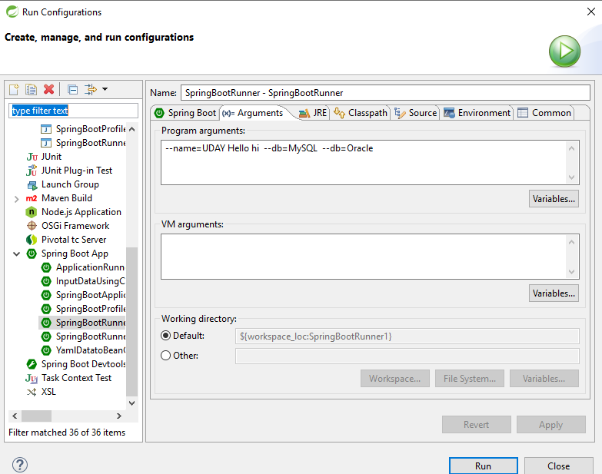

=>Click on Apply and Run

=>It is internally converted to String [] (String… args)

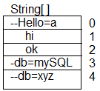

## Anonymous Inner class:--

=>A nameless class and object created for an interface having abstract methods.

=>In simple create one class without name and create object at same time without name. Used only one time.

Syntax:--

new InterfaceName() {

//Override all methods

}

**Example#1:--** interface Sample { void show ();

}

## -----Anonymous Inner class--

new Sample() { public void show() {

System.out.println(“Hello”);

}

}

## Example#2:--

interface CommandLineRunner {

void run(String… args) throws Exception;

}

## Anonymouse Inner class:--

new CommandLineRunner() {

public void run (String… args) throws Excception { System.out.println(“HI”);

} }

## **Java Style Configuration for CommandLineRunner:--

**Code:--**

package com.app;

//Ctrl+shift+O @Configuration

**public class** AppConfig {

//JDK 1.7 or before (Inner class style) @Bean

**public** CommandLineRunner cob () {

**return new** CommandLineRunner() {

**public void** run (String... args) **throws** Exception{ System.***out***.println(Arrays.*asList*(args));

} };

}

//JDK 1.8 or higher (lambda) @Bean

**public** CommandLineRunner cob2() {

**return** (args) -> {

System.***out***.println(Arrays.*asList*(args));

};

}

}

## Q>How CommandLineRunner works?

A>CommandLine arguments which are passed to application which will be given to Spring Boot starter main(..) method. Those are stored as “string Array” (String[]).

SpringApplication.run(…) reads this input and internally calls run(..) methods of RunnerImpl classes and pass same data.

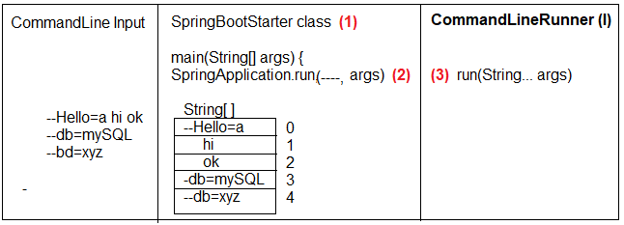

* 1. **ApplicationRunner(I) :--** It is new type runner added in Spring boot **1.3** which makes easy to access arguments.

=>This will separate Option Arguments (as Map<String, List<String>>) and Non-Option Arguments (<List<String>)

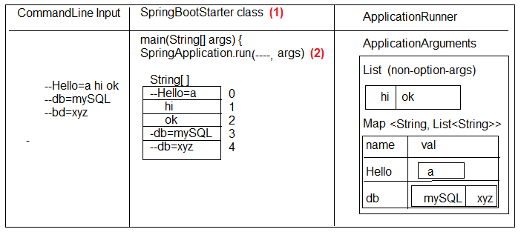=>This Data Stored in Object of “ApplicationArguments” as given below.

## 3>Runner#2 (SpringBootApplicationRunner.java):--

package com.app.runner; import java.util.Arrays;

import org.springframework.boot.ApplicationArguments; import org.springframework.boot.ApplicationRunner; import org.springframework.stereotype.Component;

@Component

public class SpringBootApplicationRunner implements ApplicationRunner { public void run(ApplicationArguments args) throws Exception {

System.out.println("hello Application Runner"); System.out.println(Arrays.asList(args.getSourceArgs())); System.out.println(args.getNonOptionArgs()); System.out.println(args.getOptionNames()); System.out.println(args.getOptionValues("db")); System.out.println(args.containsOption("bye")); System.out.println("End of Application Runner");

}

}

## Output:--

**Q> What is the difference between CommandLineArgument and ApplicationRunner?**

A> Working process of CommandLineRunner and ApplicationRunner are same, but CommandLineRunner (CLR) holds data in String[] format where as Application (AR) holds data as ApllicationArguments as Option/Non-Option format.

1. **Spring Boot Input Data (Using application.properties):--**

=>application.properties or application.yml is a primary source input to spring boot (Spring Container).

=>Spring Boot F/W writes Configuration code (XML/Java Config) for programmer.

=>Here we are not required to write (@Bean or <bean..>) configuration for common application setup like JDBC Connection, Hibernate Properties, DispatcherServlet Config, Security Beans etc..

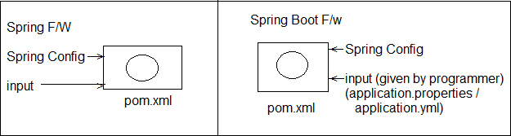=>But Programmer has to provide input to the above beans (Objects) using Properties or YAML File (any one).

## application.properties:--

1>It holds in key=value format 2>Keys are two types

a>Spring Boot defined (Predefined) Reference Link: [*https://docs.spring.io/spring-*](https://docs.spring.io/spring-%20%20%20%20%20%20%20%20%20%20%20%20%20boot/docs/current/reference/html/common-application-properties.html)[*boot/docs/current/reference/html/common-application-properties.html*](https://docs.spring.io/spring-%20%20%20%20%20%20%20%20%20%20%20%20%20boot/docs/current/reference/html/common-application-properties.html)*)*

b>Programmer defined

## #3. Folder Structure of Spring Boot Input Data using application.aproperties:--

**Code:--**

**#1.** Create maven project and provide pom.xml and starter class

**#2.** application.properties (src/main/resources)

=>Right click on src/main/resource folder=>new =>other=>search and Select “File”=>enter name “application.properties” => finish

**application.properties:--** my.info.product.id=999A my.info.product.code=xyz my.info.product.model-version=44.44 my.info.product.release_dtl_enable=false my.info.product.start-key=N

## NOTE:--

a> Allowed special symbol are **dot(.), dash(-) and underscore (_)**.

b> Key=value both are String type, Spring supports both are String type, Spring supports type conversation (ex String->int) automatically.

c> To read one key-value in code use Legacy syntax : @Value(“${key}”)

**#3.** Starter class same as above.

## #4. Runner with key data class (SpringBootRunnerWithInputData.java):-- package com.app.runner;

**import** org.springframework.beans.factory.annotation.Value; **import** org.springframework.boot.CommandLineRunner; **import** org.springframework.stereotype.Component;

@Component

**public class** SpringBootRunnerWithInputData **implements** CommandLineRunner

{

@Value("${my.info.product.id}") **private int** prodId; @Value("${my.info.product.code}") **private** String prodCode;

@Value("${my.info.product.model-version}") **private double** modelver; @Value("${my.info.product.release_dtl_enable}") **private boolean** isDetEnable; @Value("${my.info.product.start-key}")

**private char** startKey;

//Constructor methods

//Setters and Getters method

//toString method @Override

**public** String toString() {

**return** "SpringBootRunnerWithInputData [prodId=" + prodId + ", prodCode=" + prodCode + ", modelver=" + modelver+ ", isDetEnable=" + isDetEnable + ", startKey=" + startKey + "]";

}

//Overridden run method

**public void** run(String... args) **throws** Exception { System.***out***.println(**this**);

//System.out.println(this.toString());

}

}

## Output:--

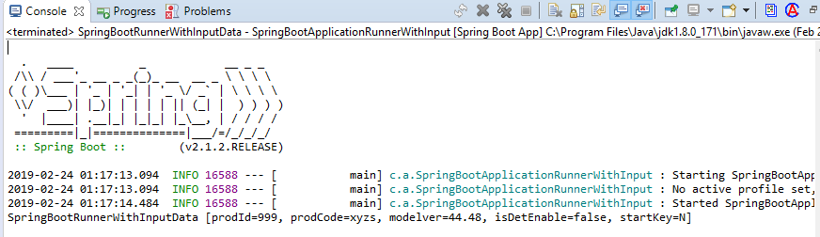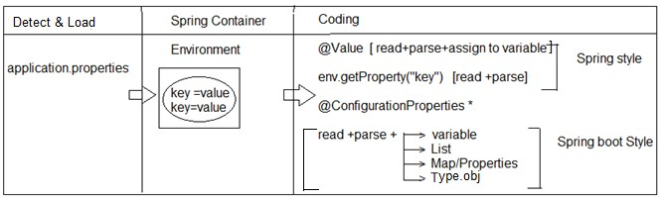

**NOTE:--** If key data is mismatched with variable data type, then Spring Container throws Exception : TypeMistchException : Failed to convert value.

## Internal flow:--

Spring Boot will search for file “application.properties” in project (4 different locations)

=>Once found (detected) then load into Container and store as “Environment” obj. 2>We can read data in legacy style @Value or 2>env.getProeprty(..).

3>Boot Style (Bulk Loading) can be done using Annotation. **** 4>@ConfigurationProperties

**4>@ConfigurationProperties:--**

=>This Annotation is used to perform bulk data reading (multiple keys at a time) and parsing into one class type (Stores in project).

=>Possible conversions are. a>1key = 1 variable

b>Multiple keys with index = List/Set/Array

c>Multiple keys with key-value format = Map or Properties d>Multiple keys with common type = Class Object (Has-A)

## #4. Input Data Using ConfigurationProperties:--

Example:--

## Starter class (SpringBootApplicationEx.java):--

package com.app;

import org.springframework.boot.SpringApplication;

import org.springframework.boot.autoconfigure.SpringBootApplication;

@SpringBootApplication public class SpringBootStarter {

public static void main(String[] args) { SpringApplication.run(SpringBootStarter.class, args); System.out.println("Hello Spring Boot");

}

}

1. **application.properties:--** #One variable data my.prod.ID=999 my.prod.co-de=ABC my.prod.Ty_pe=true my.prod.MOD-E_L=p

#List<DT>/Set<DT>/DT[] my.prod.prjnm[0]=P1

my.prod.prjnm[1]=P2 my.prod.prjnm[2]=P3

#Map or Properties my.prod.mdata.s1=55 my.prod.mdata.s2=66 my.prod.mdata.s3=88

#One class Object my.prod.dpt.dname=AAA my.prod.dpt.did=8987

#Random data generater my.random.stringval=${random.value} my.random.num=${random.int} my.random.bignum=${random.long} my.random.num-range=${random.int[10]} my.random.num-from-to=${random.int[10,100]} my.random.uuid-type=${random.uuid}

## Runner #1 class (UsingEnvironment.java):--

package com.app.input;

import org.springframework.beans.factory.annotation.Autowired; import org.springframework.boot.CommandLineRunner;

import org.springframework.core.env.Environment; import org.springframework.stereotype.Component;

@Component

public class UsingEnvironment implements CommandLineRunner{

@Autowired

private Environment env;

@Override

public void run(String... args) throws Exception { System.out.println(env.getProperty("my.prod.ID"));

System.out.println(env.getProperty("my.prod.code")); System.out.println(env.getProperty("my.prod.Ty_pe")); System.out.println(env.getProperty("my.prod.MOD-E_L"));

}

}

**Example #2:--** Load all key-value based on common prefix

** Do not provide any prefix at annotation level Make sure create variable with first level prefix before first will）

## Runner #2 class (UsingApplicationProperties):--

package com.app.input; import java.util.Arrays; import java.util.List; import java.util.Set;

import org.springframework.boot.CommandLineRunner;

import org.springframework.boot.context.properties.ConfigurationProperties; import org.springframework.stereotype.Component;

@ConfigurationProperties("my.prod") @Component

public class UsingApplicationProperties implements CommandLineRunner {

private int id; private String code;

private boolean type; private char model;

private List<String> projname; private Set<String> projname1; private String[] projname2;

public UsingApplicationProperties() { super();

}

public int getId() {

return id;

}

public void setId(int id) { this.id = id;

}

public String getCode() { return code;

}

public void setCode(String code) { this.code = code;

}

public boolean isType() { return type;

}

public void setType(boolean type) { this.type = type;

}

public char getModel() { return model;

}

public void setModel(char model) { this.model = model;

}

public List<String> getProjname() { return projname;

}

public void setProjname(List<String> projname) { this.projname = projname;

}

public Set<String> getProjname1() { return projname1;

}

public void setProjname1(Set<String> projname1) { this.projname1 = projname1;

}

public String[] getProjname2() { return projname2;

}

public void setProjname2(String[] projname2) { this.projname2 = projname2;

}

@Override

public String toString() {

return "UsingApplicationProperties [id=" + id + ", code=" + code + ", type=" + type + ", model=" + model+ ", projname=" + projname + ", projname1=" + projname1 + ", projname2=" + Arrays.toString(projname2)+ "]";

}

@Override

public void run(String... args) throws Exception { System.out.println(this.toString());

}

}

**Example #3 Generating Random Values:--**We can use a direct expression @Value(“{random.---}”) in java code or in properties file.

=>Possible random data is a>Hexa Decimal Value b>int or long type

c>int or long with range

d>UUID (Universal Unique Identifier)

## Example #3:-- 1>application.properties:--

#Random data generator my.random.stringval=${random.value} my.random.num=${random.int} my.random.bignum=${random.long} my.random.num-range=${random.int[10]} my.random.num-from-to=${random.int[10,100]} my.random.uuid-type=${random.uuid}

## 2>Model class with Runner (UsingValueAnnotation):--

package com.app.input;

import org.springframework.beans.factory.annotation.Value; import org.springframework.boot.CommandLineRunner;

import org.springframework.boot.context.properties.ConfigurationProperties; import org.springframework.stereotype.Component;

@Component

public class UsingValueAnnotation implements CommandLineRunner {

//@Value("${my.random.stringval}")

//@Value("${my.random.stringval}")

//@Value("${random..value}") @Value("${my.random.uuid-type}") private String code;

@Value("${my.random.num}")

//@Value("${my.random.num-rang}")

//@Value("${my.random.num-rang-from-to}") private int num;

@Value("${my.random.bignum}") private long numbig;

@Override

public void run(String... args) throws Exception { System.out.println(this);

}

public UsingValueAnnotation() { super();

}

public UsingValueAnnotation(String code, int num, long numbig) { super();

this.code = code; this.num = num; this.numbig = numbig;

}

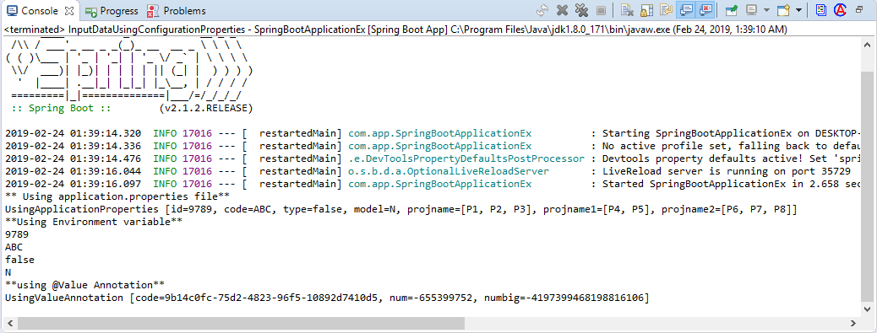

@Override

public String toString() {

return "UsingValueAnnotation [code=" + code + ", num=" + num + ", numbig=" + numbig + "]";

}

}

## Output:--

1. **Possible Locations for Properties (YAML) file:--**

=>Spring Boot supports 4 default and priority order locations, which are loaded by container for key=val data.

1> Under Project:-- Under Config folder:-- Project/config/application.properties (file:./config/application.properties)

2> Under Project (Only):--

Project/application.properties (file: ./application.properties) 3> Under Project (Under resources/config):--

Project/src/main/resources/config/application.properties (classpath:/config/application.properties)

3> Under “Project” folder:-- Project/src/main/resource/application.properties (classpath:/application.properties)

Specify Programmer File name for application.properties (even YAML)

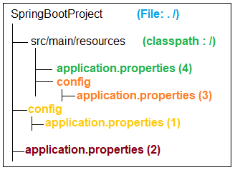

=>Spring Boot supports programmer defined Properrties (YAML) file name.

=>Which can be placed in any of 4 locations given as before (priority order is applicable if same file exist in all places).

**Step#1:-** Create your file under one location Ex:-- src/main/resources

|-mydata.properties

(or any other location also valid)

**Step#2:-** Use Run Configuration and provide option argument => apply and Run Ex:-- s--spring.config.name=mydata (user defined)

NOTE:-- To avoid default location select priority order and select exact Properties file use option argument:

Ex#1: spring.config.location=classpath:/config/mydata.properties

Ex#2: spring.config.location=file:./config/mydata.properties

## #5. Folder Structure of Possible application.properties/application.yml Locations:--

1. **YAML (YAMlian Language):--**

=>It is representation style of key=val without duplicate levels in keys if they are lengthy and having common levels.

=>File extension is “.yml”.

=>It will hold data in below format key : <space> value

=>Default name used in Spring boot is application.yml.

=>At least one space must be used but same should be maintaining under same level.

=>Spring Boot System converts .yml to .properties using SnakeYaml API.

=>Snake YAML will

a>Check for space and prefix levels b.>Trace keys for data find.

c>Convert .yml to .properties internally system is while loading.

=>Consider below example properties file

-=-=- “application.properties” -=-=- Ex#1:-

my.data.id-num=10 my.data.core_val=AB my.data.enabled.costBit=3.6 my.data.enabled.valid=true

Ex#2:--

my.code.id=56 my.code.mdn.type=big my.code.str.service=ALL my.code.str.service.info=true my.code.mdn.obj=CRL my.code.cost=3.67 my.code.mdn.sale=YES

=>Its equal YAML file looks as

-=-=- application.yml-=-=-

my:

code:

id: 56

cost: 3.67 mdn:

type: big obj: CRL sale: YES

str:

service: ALL

info: true

=>Key=value format List<DataType>/Set<DataType>/Array(<DataType>[]) Style:--

=>In properties file we can use from zero.

=>In yml file use just dash (-) with <space> value under same level.

Ex:-- application.proeprties--- my.code.version[0]=V1 my.code.version[1]=V2 my.code.version[2]=V3

---application.yml:--- my:

code:

version:

-V1

-V2

-V3

=>final meaning is:

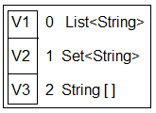

=>Key=value format Map/Properties Style:--

=>Consider below example:--

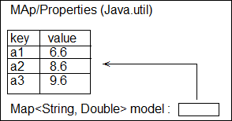

=>Its equal properties file will be Ex:-- application.properties my.data.model.a1=6.6 my.data.model.a2=8.6 my.data.model.a3=9.6

=>Its equal : application.yml file my:

data:

model:

a1: 6.6

a2: 8.6

a3: 9.6

## #6. Example Application for application.yml properties:--

**1>pom.xml**

=>Add one extra dependency for auto detection of keys in properties/yml file.

<dependency>

<groupId>org.springframework.boot</groupId>

<artifactId>spring-boot-configuration-processor</artifactId>

<optional>true</optional>

</dependency>

## >Write starter class (same as before) [main method]

package com.app;

import org.springframework.boot.SpringApplication;

import org.springframework.boot.autoconfigure.SpringBootApplication;

@SpringBootApplication

public class ApplicationProperiesUsingYml { public static void main(String[] args) {

SpringApplication.run(ApplicationProperiesUsingYml.class, args);

}

}

## >application.yml:--

#Normal Data my:

prod:

id: 5 code: AB cost: 4.5

#List Data

version:

-V1

-V2

-V3

#Map Data

model: a1: 6.6

a2: 8.6

a3: 9.6

## 4>Write Model class (Product.java):--

package com.app.model; import java.util.List; import java.util.Map;

import org.springframework.boot.context.properties.ConfigurationProperties; import org.springframework.stereotype.Component;

@ConfigurationProperties("my.prod") @Component

public class Product {

private int id; private String code; private double cost;

private List<String> version;

private Map<String, Double> model;

public Product() {

super();

}

public Product(int id) { super();

this.id = id;

}

public Product(int id, String code, double cost, List<String> version, Map<String, Double> model) {

super(); this.id = id;

this.code = code; this.cost = cost; this.version = version; this.model = model;

}

public int getId() {

return id;

}

public void setId(int id) {

this.id = id;

}

public String getCode() { return code;

}

public void setCode(String code) { this.code = code;

}

public double getCost() { return cost;

}

public void setCost(double cost) { this.cost = cost;

}

public List<String> getVersion() { return version;

}

public void setVersion(List<String> version) { this.version = version;

}

public Map<String, Double> getModel() { return model;

}

public void setModel(Map<String, Double> model) { this.model = model;

}

@Override

public String toString() {

return "Product [id=" + id + ", code=" + code + ", cost=" + cost + ", version=" + version + ", model=" + model+ "]";

}

}

## 5. Runner class (ApplicationRunnerEx implements.java):--

package com.app.runner; import java.util.Arrays;

import org.springframework.beans.factory.annotation.Autowired;

import org.springframework.boot.ApplicationArguments; import org.springframework.boot.ApplicationRunner; import org.springframework.stereotype.Component; import com.app.model.Product;

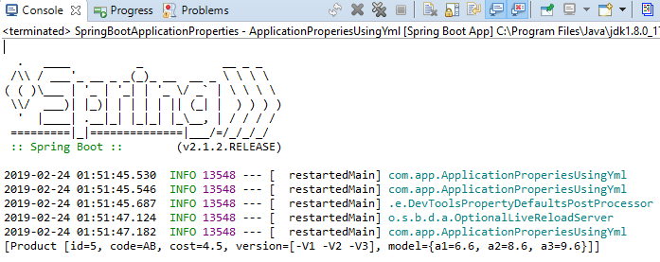

@Component

public class ApplicationRunnerEx implements ApplicationRunner { @Autowired

private Product prod; @Override

public void run(ApplicationArguments args) throws Exception { System.out.println(Arrays.asList(prod));

}

}

## Output:--

**Yaml Data to Bean/POJO:--**

=>At a time multiple values (key pair) can be converted to one POJO (Java Bean/ Spring Bean) using @ConfigurationProperties annotation.

## POJO Rules :--

1>Class, variable **default constructor with set/get methods.

2>Java Bean :-- POJO Rules + Inheritance + Special methods + Param constructor. 3>Spring Bean:-- OJO Rules + Inheritance (Spring API) + Annotations (Spring API) + Special methods (Object class and Spring API) [toString()…]

## #7. Folder Structure for providing Yaml data to Bean / POJO:--

Example Code:--

**#1 Starter class + pom.xml:--** Same as before @SpringBootApplication

**public class** SpringBootStarter {

**public static void** main(String[] args) { SpringApplication.*run*(SpringBootStarter.**class**, args); System.***out***.println("Hello Spring Boot");

}

}

## #2. application.yml:--

my:

dt:

pid: 55 mo:

mid: 67 mcode: ABC colors:

-RED

-GREEN

-YELLOW

**#3. Model class #1(Child ) Model-- package** com.app.bean;

**import** java.util.List;

**import** org.springframework.stereotype.Component; @Component

**public class** Model {

**private int** mid;

**private** String mcode;

**private** List<String> colors;

**public** Model() {

**super**();

}

**public int** getMid() {

**return** mid;

}

**public void** setMid(**int** mid) {

**this**.mid = mid;

}

**public** String getMcode() {

**return** mcode;

}

**public void** setMcode(String mcode) {

**this**.mcode = mcode;

}

**public** List<String> getColors() {

**return** colors;

}

**public void** setColors(List<String> colors) {

**this**.colors = colors;

}

@Override

**public** String toString() {

**return** "Model [mid=" + mid + ", mcode=" + mcode + ", colors=" + colors + "]";

}

}

**#4. Model class(Parent) Product :-- package** com.app.bean;

**import** org.springframework.beans.factory.annotation.Autowired;

**import** org.springframework.boot.context.properties.ConfigurationProperties;

**import** org.springframework.stereotype.Component;

@ConfigurationProperties("my.dt") @Component

**public class** Product

{

**private int** pid;

@Autowired

**private** Model mo; //HAs-A

**public** Product() {

**super**();

}

**public int** getPid() {

**return** pid;

}

**public void** setPid(**int** pid) {

**this**.pid = pid;

}

**public** Model getMo() {

**return** mo;

}

**public void** setMo(Model mo) {

**this**.mo = mo;

}

@Override

**public** String toString() {

**return** "Product [pid=" + pid + ", mo=" + mo + "]";

}

}

**#5. Runner class (CommandLineRunnerForYaml):-- package** com.app.runner;

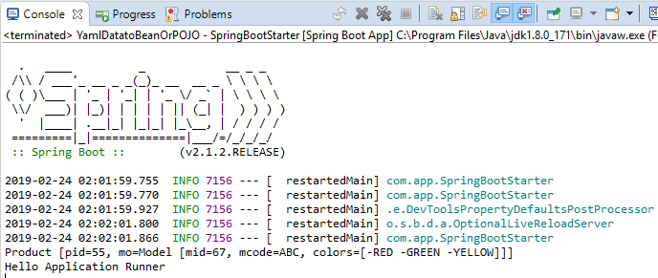

**import** org.springframework.beans.factory.annotation.Autowired;

**import** org.springframework.boot.CommandLineRunner; **import** org.springframework.stereotype.Component; **import** com.app.bean.Product;

@Component

**public class** CommandLineRunnerForYaml **implements** CommandLineRunner

{

@Autowired

**private** Product pob;

**public void** run(String... args) **throws** Exception { System.***out***.println(pob); System.***out***.println("Hello Application Runner");

}

}

## Output:--

**Place Holder Process in yml or properties:--**

=>Internal place holders are used to re-use existed key value for another key as a part or full.

=>Read as ${fullPathKey} (it must be properties style even in yml file)

**application.properties:--** my.dt.pid=68 my.dt.mid=${my.dt.pid}

## application.yml:--

my:

dt:

pid: 68

mid: ${my.dt.pid}

## NOTE:--

1. >Symbol ‘#’ indicates a comment line in yml file.
2. >Using 3 dash (---) symbols in yml is divided into multiple files internally (mainly used for profiles**)

Ex:-- application.yml:-- #Hello data to Product my:

dt

---

my:

pid: 57

dt:

do:

mid: 98

**NOTE:--**Priority order for .yml is same as .properties file. 3.>Search locations in order

a>file:./config b>file:./ c>classpath:/config d>classpath:/

**file:./ = Under project folder classpath:/ = Under src/main/resources

## Priority Order for key Search:--

=>Spring boot has provided default priority to “Option Arguments” (Command Line Args).

1>With format –key=value

2>If not found, next level is .properties. 3>else finally chosen .yml

4>No-where found default value

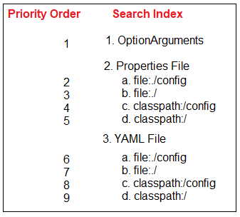

**NOTE:--** If no key is matched then it will give default value(Int/long=0, double=0.0, String=null), but not given any Exceptions.

## Q>What are the Difference between @ConfigurationProperties & @Value:--

1. **Spring Boot Profiles:--**

=>In RealTime, Application is

* + Developed in =>Dev Environment
  + Tested in =>Quality Analyst (QA) Environment
  + Maintained in =>PROD Environment
  + Client tested in =>UAT Environment
  + Go live in =>Cloud / prod Environment

***>Environment is place where our application is running or what is current state of application

Example:-- dev= development

* + QA = Quality Analysis,
  + MS = Management Service,
  + PROD = Production
  + UAT = User acceptance Testing
  + Cloud = Cloud Environment

=>In this case we should not modify existed properties file, use new one with key=val data. File naming rule is:

## application-{profile}.properties application-{profile}.yml (or 3 dash)

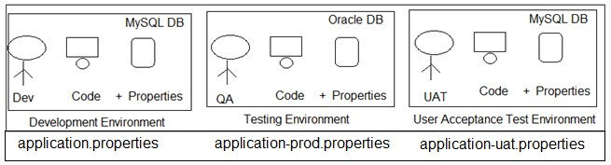

**Profile Specific Tasks:--**

=>Profile supports Environment based Code (Task) selection, not only Properties (yaml).

=>But in this case class should have @Profile(“---“) with @Configuration or @Component (or its equal StereoType).

=>StereoType Annotations are:-- @Component, @Repository, @Service, @Controller, @RestController.

=>Consider example Profiles default Production (prod), User Acceptance Test (uat) then.

|  |  |  |
| --- | --- | --- |
| **Profile Code** | **Properties File** | **Class level Annotation** |
| Default | application.properties | @Profile(“default”) |
| Prod | application-prod.properties | @Profile(“prod”) |
| Uat | application-uat.properties | @Profile(“uat”) |
| Qa | application-qa.properties | @Profile(“qa”) |
| Cloud | application-cloud.properties | @Profile(“cloud”) |

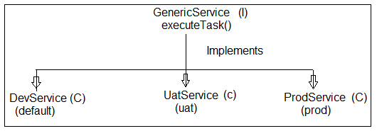

## Example:--

=>File => new => Spring Starter Project => Enter Details Project Name : SpringBootProfiles and also

GroupId : org.sathyatech ArtifactId : SpringBootProfiles Version : 1.0

=> next => next => finish.

## #8. Folder structure of Spring Boot Profiles using application.properies:--

**1>Starter class (SpringBootProfilesApplication.java):--**

package com.app.profile;

import org.springframework.boot.SpringApplication;

import org.springframework.boot.autoconfigure.SpringBootApplication;

@SpringBootApplication

public class SpringBootProfilesApplication { public static void main(String[] args) {

SpringApplication.run(SpringBootProfilesApplication.class, args); System.***out***.println("**Starter class Executed**");

}

}

## 2>Properties files:--

a>application.properties

Ex:-- my.profile.code=Hello from default b> application-prod.properties

Ex:-- my.profile.code=Hello from PROD

c> application-uat.properties

Ex:-- my.profile.code=Hello from UAT d> application-qa.properties

Ex:-- my.profile.code=Hello from QA

## 3>service interface:--

**#1 Create an Interface (GenericService.java):-- package** com.app.profile.service;

**public interface** GenericService {

**public void** executeTask();

}

## 4>Create Multiple classes like and implements GenericService interface:--

1. **DevService.java:--**

**package** com.app.profile.service.impl;

**import** org.springframework.beans.factory.annotation.Value; **import** org.springframework.context.annotation.Profile; **import** org.springframework.stereotype.Component;

**import** com.app.profile.service.GenericService;

@Component @Profile("default")

**public class** DevService **implements** GenericService { @Value("${my.profile.code}")

**private** String code;

**public** DevService(String code) {

**super**(); **this**.code = code;

}

**public** String getCode() {

**return** code;

}

**public void** setCode(String code) {

**this**.code = code;

}

@Override

**public** String toString() {

**return** "DevService [code=" + code + "]";

}

@Override

**public void** executeTask() { System.***out***.println("From Dev Profiles"); System.***out***.println("code is "+code);

}

}

## ProdService.java:--

package com.app.profile.service.impl;

import org.springframework.beans.factory.annotation.Value; import org.springframework.context.annotation.Profile; import org.springframework.stereotype.Component;

import com.app.profile.service.GenericService;

@Component @Profile("prod")

public class ProdService implements GenericService {

@Value("${my.profile.code}") private String code;

public ProdService() { super();

}

public ProdService(String code) { super();

this.code = code;

}

public String getCode() { return code;

}

public void setCode(String code) { this.code = code;

}

@Override

public String toString() {

return "ProdService [code=" + code + "]";

}

public void executeTask() { System.out.println("From Prod Profile"); System.out.println("code is "+code);

}

}

## UatService class:--

package com.app.profile.service.impl;

import org.springframework.beans.factory.annotation.Value; import org.springframework.context.annotation.Profile; import org.springframework.stereotype.Component;

import com.app.profile.service.GenericService;

@Component @Profile("uat")

public class UatService implements GenericService { @Value("${my.profile.code}")

private String code;

public String getCode() { return code;

}

public void setCode(String code) { this.code = code;

}

@Override

public String toString() {

return "UatService [code=" + code + "]";

}

public void executeTask() { System.out.println(this); System.out.println("From Uat Profiles");

System.out.println("code is "+code);

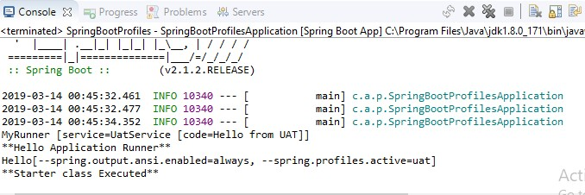

}

}

## Execution of Program:--

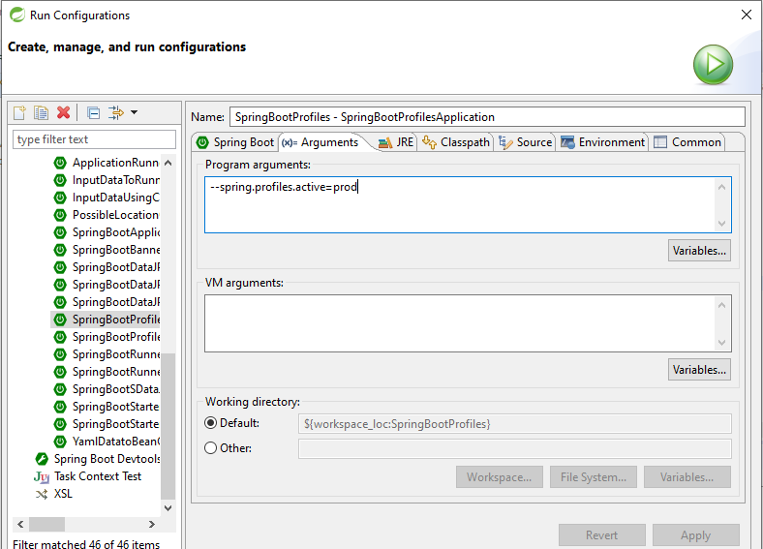=>Run As => Run configurations… and provide below details in Argument tab field.

## Output:--

**NOTE:--**

1>Use key spring.profiles.active=profile

=>We can provide using 3 ways. Those are

a> Command Line Arguments (Option Arguments)

Ex spring.profiles.active=prod

b>In application.proeprties

Ex:-- spring.profiles.active=prod b> VM (JVM/System) Argument:--

Ex Dspring.profiles.active=prod

=>Right click on Starter class => Run As=> Run Config =>Choose Arguments

=>Enter below format in VM Arguments

-Dspring.profiles.active=prod

=>apply and Run

2>Key Search highest priority is given in same profile properties file, if key is not found in current profile properties file then goes to default properties file.

=>If no where key is found then

a>@Value generate Exception (IllegalArgumnetException) b>@ConfigurationProperties :- Default value of DataType is chosen by container.

|  |  |  |
| --- | --- | --- |
| **application.properties** | **application-prod.properties** | **application-uat.properties** |
| A=10 | A=15 | A=30 |
| B=7 | B=20 |  |
| C=6 |  |  |

## Case#1 spring.profiles.active=prod then

|  |  |
| --- | --- |
| **Key** | **Value** |
| A | 15 |
| B | 20 |
| C | 6 |
| D | 0 ( for int type default value) |

**Case#2 spring.profiles.active=uat**

|  |  |
| --- | --- |
| **Key** | **Value** |
| A | 30 |
| B | 7 |
| C | 6 |
| D | 0 (for int type default value) |

## Including Child Profiles:--

=>In spring Boot applications active profile can be specified using key Ex: --spring.profiles.active=[ ]

=>In this case one properties file is loaded into memory which may have more set of key=value pairs.

=>These can be divided into multiple child properties file and loaded through active profile, also called as “Profiles Include”.

=>This can be done using key spring.profiles.include=-,-,-,-

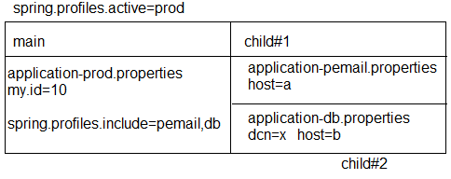

## Spring Container will load:--

=>Parent (main) Profiles first (all its key=value pairs)

=>Then child profiles in given order will be loaded.

=>For above example, priority for loading (loading order is) a>application-prod.properties

b>application-pemail.properties c>application-db.properties

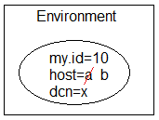

## Profiles using YAML:--

=>YAML Files also works same as Properties file for both “active and include” profiles.

=>File Naming Rule:- application-{profile}.yml **Example:--**

application.yml (default) application-prod.yml (prod) application-uat.yml (uat)

## Multiple Profiles using one YAML:--

=>YAML File supports using writing multiple profiles in one file using symbol 3 dash.

## application.yml:--

my:

profile:

id: 666

---

my:

profile:

id: 999

spring:

profiles: prod

---

my:

profiles:

id: 888 spring:

profiles: uat

## NOTE:--

#1 To specify active and include profiles use

## a>Option Arguments:--

--spring.profiles.active=prod

--spring.profiles.include=prodemail

**b>use Properties file:--** spring.profiles.active=prod spring.profiles.include=prodemail

## c>use YAML file:--

spring:

profiles:

active: prod include:

-prodemail

## #9. Folder Structure of include & active properties in Profiles using Yml:--

**1>Starter and pom.xml same as before:--**

package com.app;

import org.springframework.boot.SpringApplication;

import org.springframework.boot.autoconfigure.SpringBootApplication;

@SpringBootApplication

public class SpringBootProfilesUsingYmlApplication { public static void main(String[] args) {

SpringApplication.run(SpringBootProfilesUsingYmlApplication.class, args);

}

}

## 2>application.yml:--

my:

profile:

id: 666

spring:

profiles:

active: prod include:

-prodemail #Production Profiles

---

my:

profile:

id: 999

spring:

profiles: prod #Uat profiles

---

my:

profile:

id: 888

spring:

profiles: uat #Prodemail profile

---

my:

profile:

email: [udaykumar0023@gmail.com](mailto:udaykumar0023@gmail.com)

spring:

profile: prodemail

## 3.>Bean and Runner class (ProductRunner.java):--

package com.app.bean;

import org.springframework.boot.CommandLineRunner;

import org.springframework.boot.context.properties.ConfigurationProperties; import org.springframework.stereotype.Component;

@Component @ConfigurationProperties("my.profile")

public class ProductRunner implements CommandLineRunner {

private int id; private String email;

public ProductRunner() { super();

}

public int getId() {

return id;

}

public void setId(int id) { this.id = id;

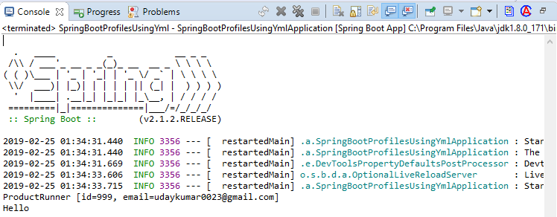

}

public String getEmail() { return email;

}

public void setEmail(String email) { this.email = email;

}

@Override

public String toString() {

return "ProductRunner [id=" + id + ", email=" + email + "]";

}

public void run (String... args)throws Exception{ System.out.println(this);

}

}

## Output:--

1. **pom.xml (Maven Process) : --**

=>Maven is Dependency management and build tool used to handle both stand alone and Archetype (web, restful…) applications.

## Dependency Management:--

Getting Main Jars and its child jars with version support (without conflicts) into project workspace is called as Dependency Management.

**Build:--** Converting our application into final JAVA executable format i.e .jar/.war/.ear.

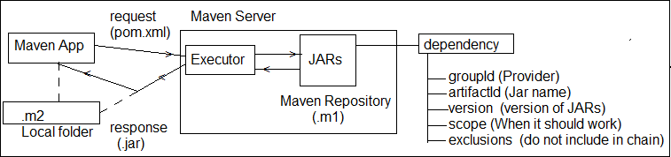

## Major components of pom.xml:--

1>Current Project 2>Parent Project 3>Dependencies 4>Build plugins

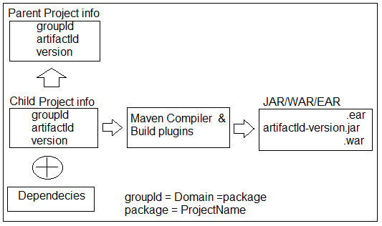

## pom.xml format:--

<project….>

<modelVersion>4.0.0</modelVersion>

<!-- CUrrent Project info -->

<groupId>a.l</groupId>

<artifactId>HelloApp</artifactId>

<version>1.0</version>

<!-- Parent Project info -->

<parent>

<groupId>a.a</groupId>

<artifactId>DBApp</artifactId>

<version>6.1</version>

<relativePath/> <!-- lookup parent from repository -->

</parent>

<!-- Current Project info -->

<properties>

<java.version>1.8</java.version>

</properties>

<!-- Project JARs Dtails -->

<dependencies>

<dependency>

<groupId>a.b</groupId>

<artifactId>Web-Test</artifactId>

<version>5.6</version>

<scope>compile</scope>

<exclusions>

<exclusion>

<groupId>xyz.com</groupId>

<artifactId>Web.abc</artifactId>

</exclusion>

</exclusions>

</dependency>

</dependencies>

<!—Plugins Details -->

<build>

<plugins>

<plugin>

<groupId>org.maven..</groupId>

<artifactId>maven-compiler</artifactId>

</plugin>

</plugins>

</build>

</project>

## Dependency exclusions:--

=>When <dependency> tag is added in pom.xml then it will download Parent jars and all its child jars also.

=>To avoid any one or more child jars from chain, use concept called exclusion.

Syntax:--

<dependencies>

<dependency>

<groupId>..</groupId>

<artifactId>..</artifactId>

<version>..</version>

<exclusions>

<exclusion>

<groupId>..</groupId>

<artifactId>..</artifactId>

</exclusion>

</exclusions>

</dependency>

</dependencies>

Ex:--

<dependencies>

<dependency>

<groupId>org.springframework</groupId>

<artifactId>spring-webmvc</artifactId>

<version>5.1.5</version>

<exclusions>

<exclusion>

<groupId>org.springframework</groupId>

<artifactId>spring-core</artifactId>

</exclusion>

</exclusions>

</dependency>

</dependencies>

## Scope (<scope> </scope> in dependency:--

=>For every dependency one scope is given by maven i.e. default scope : **compile**.

=>This tag is optional and indicates when a JAR should be used/loaded.

## POM format:--

<dependency>

<groupId>…</groupId>

<artifactId>…</artifactId>

<scope>….</scope>

</dependency>

## Possible Maven dependency scopes are (5) :--

**1>compile:--** A jar Required from compilation time onwards. It is only default scope.

**2>runtime :--** A jar required when we are running an Application, not before that.

**3>test :--** A Jar required only for UnitTesting time.

**4>provided :--** A jar provided by servers or Frameworks (Container….).

**5>system:--** A Jar loaded from File System (like D:/abc/myjar/…)

=>In this case we should also give <SystemPath> with location of JAR. Ex:-- <systemPath>D:/asf/lib/</systemPath>

**NOTE:--** There is a dependency jar which not existing in the maven centre but locally. After mvn clean install, this dependency jar can't be found from the fat jar. is this an known-issue? the workaround is have to install it into local maven repo with command:

`mvn install:install-file -Dfile=lib/routines.jar -DgroupId=org.talend - DartifactId=routines -Dversion=1.0 -Dpackaging=jar`

=>Then using normal dependency format in the pom.xml like this:

<dependency>

<groupId>org.talend</groupId>

<artifactId>routines</artifactId>

<version>1.0</version>

</dependency>

## Format of Scope:--

<dependencies>

<!-- Compiler time (Default) Execution -->

<dependency>

<groupId>org.springframework.boot</groupId>

<artifactId>spring-boot-starter</artifactId>

<scope>compile</scope> <!-- Optional -->

</dependency>

<!-- Runtime Execution -->

<dependency>

<groupId>com.h2database</groupId>

<artifactId>h2</artifactId>

<scope>runtime</scope>

</dependency>

<!-- Test time Execution -->

<dependency>

<groupId>org.springframework.boot</groupId>

<artifactId>spring-boot-starter-test</artifactId>

<scope>test</scope>

</dependency>

<!—framework or container time Execution -->

<dependency>

<groupId>javax.servlet</groupId>

<artifactId>javax.servlet-api</artifactId>

<version>4.0.0</version>

<scope>provided</scope>

</dependency>

<!—From local system Execution -->

<dependency>

<groupId>routines</groupId>

<artifactId>routines</artifactId>

<version>1.0</version>

<scope>system</scope>

<systemPath>${basedir}/lib/routines.jar</systemPath>

</dependency>

</dependencies>

## Maven Goals Execution:--

**1>Maven clean:--** It is used to clear target folder in maven project. i.e delete all old files from target.

**2>Maven install :--** It will downloaded all required plugins and also

=>compile the source files.

=>load required properties.

=>Execute JUnit Test cases.

=>Create final build (.jar/.war).

## #1. clean :--

=>right click on project => Run As => Maven clean

## #2. install:--

**=>**right click on project => Run As =>Maven install.

## #3. Build:--

=>right click on project => Run As => maven build.. =>provide goals like clean install

=> Also choose skipTests =>Apply and Run.

=>Update JDK to project before install or build else “BUILD FAILED” Error will be displayed.

=>A final jar will be created with same format **“artifactId-version.jar”**

=>Maven Build Plugin (integrated with Spring Boot) must be provided in pom.xml. Ex:--

<plugin>

<groupId>org.springframework.boot</groupId>

<artifactId>spring-boot-maven-plugin</artifactId>

</plugin>

## Version Management in Spring Boot Application:--

=>For all required dependencies (mostly used Spring Boot Parent Project provided fixed and stable version management.

=>To see all jars provided with what version, a.>Goto pom.xml

b.>Ctrl + Mouse over <artifactId> then click

c.>Search for tag properties

1. **Spring Boot Starter class Concepts:--**

=>A revolving period of upto two years subject to certain amortization events.

=>Spring Boot Starter class uses run (..) method from class “**SpringApplication**” defined in package : **org.springframework.boot** which creates Spring container using “**AnnotationConfigApplicationContext (C)**”

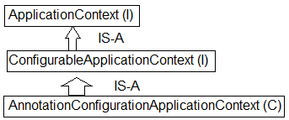

=>In case of Web/WebServices, Container is created using classes “**AnnotationServletWebServerApplicationContext (C)**”.

## NOTE:--

1>ApplicationContext can be customized even using it supportive methods and API Types.

Ex:--

* 1. >For banner use Banner.Mode.Property, Banner.Mode.OFF (to turn off banner)
  2. >Mode is Inner enum defined in functional Interface “Banner”.
  3. >We can provide our own banner using file : banner.txt (Create under classpath)

i.e : src/main/resource/banner.txt (file) (<https://devops.datenkollektiv.de/banner.txt/index.html>)

## 10. Folder Structure of Banner in Spring Boot:--

**1>SpringBootBannerApplication.java:--**

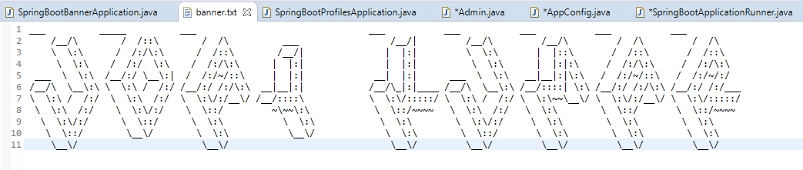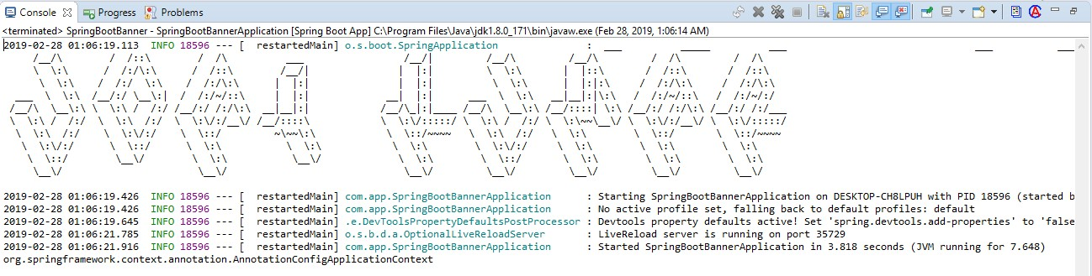

package com.app;

import org.springframework.boot.Banner;

import org.springframework.boot.SpringApplication;

import org.springframework.boot.autoconfigure.SpringBootApplication; import org.springframework.context.ConfigurableApplicationContext;

@SpringBootApplication

public class SpringBootBannerApplication

{

public static void main(String[] args)

{

SpringApplication sa = new SpringApplication (SpringBootBannerApplication.class);

//sa.setBannerMode(Banner.Mode.OFF); //to Disable the banner

//sa.setBannerMode(Banner.Mode.CONSOLE); //to Disable the banner on console sa.setBannerMode(Banner.Mode.LOG); //to Display the banner in Log file

//some other configuration ConfigurableApplicationContext c = sa.run(args); System.out.println(c.getClass().getName().toString());

}

}

## 2>Banner.txt file:--

**Output with Banner:--**

## Use of Starter class:--

1>Define Spring Container.

=>Spring container holds all required beans (Objects), this is created using Impl class.

**AnnotationConfigApplicationContext** (C) for simple (non-server) based application.

=>For server based Application, Impl class is :

## AnnotationConfigServletWebServerApplicationContext (C).

2> Here “Starter class Package” behaves as basePackage, if nothing is provided by programmer.

=>If Programmer writes externally @ComponentScan then Starter class package never taken as basePackage.

=>Spring Boot starter class package behaves as base package for componentScan of all classes having annotated with @Component [or its equal].

=>Annotations are : (class should have any one) a>@Component

b>@Repository c>@Service d>@Controller e>@RestController f>@Configuration

**Consider below starter class:--** package com.app; @SpringBootApplication

//@ComponentScan(“com.app”) -->Added by Spring Boot public class MyStarter {…….}

=>In this case only classes under package “app” and its sub package classes are detected by Spring (Boot) Container by default.

=>Programmer can provide externally basePackage using @ComponentScan

a>Avoid Starter class package and provide our own. Ex:-- @ComponentScan (“com.app”)

=>In this case Starter package classes are not included.

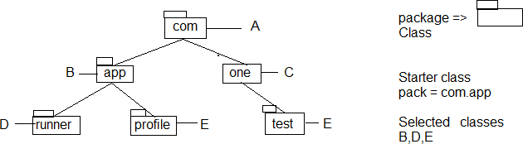

b>Provide our own starter package (even other packages) using array style {-,-,-,-,} Ex:-- @ComponentScan({“com.app”,”com.one”,”com”})

c>We can provide one common package name which covers all sub-levels. Ex:-- @ComponentScan(“com”)

**Example:-- package** com.app;

@SpringBootApplication

//@ComponentScan("com.one") @ComponentScan("com")

//@ComponentScan({"com.one", "com", "com.app"})

**public class** MyStarter {

**public static void** main (String[] args)

{

StringApplication s = **new** SpringApplication(AppStarter.**class**); ConfigurableApplicationContext ac = s.run(args); System.out.println(ac.getClass().getName());

System.out.println(ac.getBean(“Product”)); System.out.println(ac.getBean(“Info”));

}

}

3.> Every Spring Boot Application Starter class itself Component. i.e @SpringBootApplication is having @Component annotation internally.

=>It is only highest Priority component by default, if app has multiple components. Ex:- We can convert starter even as Runner.

**package** com.app;

**import** org.springframework.boot.CommandLineRunner;

@SpringBootApplication

public class MyStarter implements CommandLineRunner { public void run (String… args) throws Exception {

System.out.println(“From Starter”);

}

**public static void** main(String[] args) { SpringApplication.*run*(MyStarter.**class**, args); System.***out***.println("**Starter class Executed**");

}

}

4> Auto-Detect and Execute Configuration classes [Auto-Load Configuration files]

=>Every Spring Boot starter class itself A configuration class (@Configuration) which auto detects other Config Classes even without @Import annotation.

i.e. We can define @Bean (Objects creation in Starter class).

=>All Spring (Java based) Configuration files are loaded into container with

## @Configuration.

=>All Spring (java based) Configuration files are loaded into container by spring boot if classes are annotated with @Configuration.

=>Not required to pass as ApplicationContext input (as like Spring f/w).

## 11. Folder Structure of Starter class with AutoConfiguration, import:--

**1>Model classes a>Admin.java:--**

package com.app.model;

public class Admin

{

private int adminId; private String adminName;

public Admin() {

super();

}

public int getAdminId() { return adminId;

}

public void setAdminId(int adminId) { this.adminId = adminId;

}

public String getAdminName() { return adminName;

}

public void setAdminName(String adminName) { this.adminName = adminName;

}

@Override

public String toString() {

return "Admin [adminId=" + adminId + ", adminName=" + adminName + "]";

}

}

## b>Product.java:--

package com.app.model; public class Product {

private int prodId; private String prodName;

public Product() {

super();

}

public int getProdId() { return prodId;

}

public void setProdId(int prodId) { this.prodId = prodId;

}

public String getProdName() { return prodName;

}

public void setProdName(String prodName) { this.prodName = prodName;

}

@Override

public String toString() {

return "Product [prodId=" + prodId + ", prodName=" + prodName + "]";

}

}

## 2>AppConfig.java:--

package com.app.config;

import org.springframework.context.annotation.Bean;

import org.springframework.context.annotation.Configuration; import com.app.model.Admin;

@Configuration

public class AppConfig { @Bean

public Admin aobj() {

Admin a = new Admin(); a.setAdminId(100); a.setAdminName("Uday"); return a;

}

}

## 3>Starter class:--

package com.app;

import org.springframework.beans.factory.annotation.Autowired; import org.springframework.boot.CommandLineRunner;

import org.springframework.boot.SpringApplication;

import org.springframework.boot.autoconfigure.SpringBootApplication; import org.springframework.context.annotation.Bean;

import org.springframework.context.annotation.Import; import com.app.config.AppConfig;

import com.app.model.Admin; import com.app.model.Product;

@SpringBootApplication

//@Import (AppConfig.class) //Its not required

public class SpringBootStarterApplicationWithRunner implements CommandLineRunner

{

@Autowired private Product p; @Autowired private Admin a;

public void run(String... args)throws Exception { System.out.println("From starter class :"+p); System.out.println("From starter class :"+a);

}

public static void main(String[] args) { SpringApplication.run(SpringBootStarterApplicationWithRunner.class, args);

System.out.println("**Starter class main method executed");

}

@Bean

public Product proj() {

Product p = new Product(); p.setProdId(300); p.setProdName("Mobile"); return p;

}

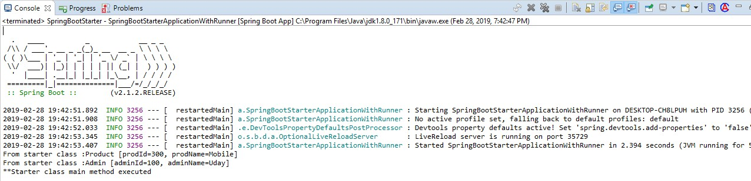

}

## Output:--

**8. Spring Initializer:--**

Link : <https://start.spring.io/>

=>This web site is used to generate one Maven (or Grade Project) for Spring Boot Apps with all configuration and setup.

Like starter class, application.properties, pom.xml, folder system etc.

=>By using this we can Create Boot App which can be imported to normal Eclipse IDE or any other equal (No STS Required).

=>Even STS (or Manual Approaches) uses **internally SPRING INITIALIZER** only.

**Step#1:-** Open Browser and type URL <https://start.spring.io/>

**Step#2:-** Provide all details and click on generate Project. **Step#3:-** It will be downloaded as .zip, Extract this to one Folder. **Step#4:-** Open Eclipse (or any IDE), then

>Right click on Project Explorer

>Choose Import => type maven

>select Existed Maven Project

>***Enter/browse location of extracted folder where pom.xml is available

>Click enter => choose next/finish

# CHAPTER#2: SPRING BOOT DATA JPA

**1. Introdution about Data-JPA:--**

**#1:-** Data JPA provides **@NoRepositoryBean** (S) which is auto configured and self logic implemented for basic operations i.e : Programmer not required to write any logic for basic operations (No Implementation class and method).

=>Configuration for DataSource (I), SessionFactory (I), HibernateTemplate (C) Hibernate TransactionManger (C) all are not required.

=>When we add bellow dependency in pom.xml it will download Jars and above Config code given from parent Project.

<dependency>

<groupId>org.springframework.boot</groupId>

<artifactId>Spring-boot-starter-data-jpa</artifactId>

</dependency>

**#2:-** Data JPA provides “**Embedded Database Support**”. It means Database provided in application itself.

=>It is not required to download and Install, not even properties required (like driver class, url, user, password).

=>Spring Boot supports 3 Embedded DBs. Those are : H2**, HSQLDB, Apache Derby.**

=>We can use any one Embedded Database which runs in RAM (Temp memory).

=>It uses hbm2ddl.auto=create-drop i.e Tables created when App starts and deleted before App Stops.

=>These DBs are used in both Development and Testing Environment, but not in Production.

**#3:-** Spring Boot also supports Both SQL (MySQL, Oracle) and NoSQL (MongoDB) Database etc.. also.

**#4:-** Data JPA Supports Special concept “Query Methods an easy way to code and fetch data from DB” (ex : findBy, @Query).

**#5:-** Data JPA supports Easy Connection Pooling (Auto Config) concept.

**#6:-** Data JPA supports Cache Management (AutoConfig).

## Repository Interfaces:--

=>Data JPA has provided Repository Interfaces in package “org.springframework.data.repository”.

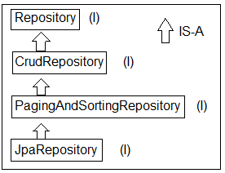

## Spring Boot Data JPA Module Design:--

Required:

1> Database (Using Embedded : H2) 2> Model class : Product (C)

3> Repository : ProductRepository 4> Runner : ConsoleRunner

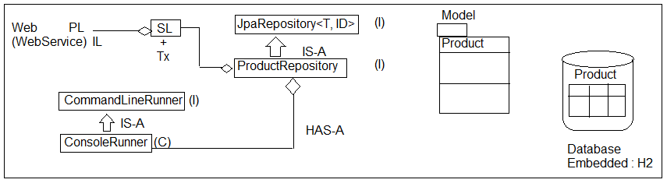

T = ? = Model class Name

ID = ? = Pk DataType = Integer

=>Primary key data Type must be Wrapper class or any other classes which implements **java.io.Serializable**.

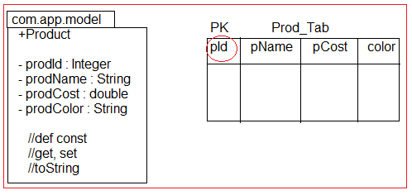

=>**Primitive Types** are not accepted as PK DataType for model & for Repository Coding.

## Eclipse Shortcuts:--

F3 => Goto code

F3 => Overview (Press again for super type also) Crtl +alt +DownArraw => Copy current line, paste

Select Lines

+ctrl + shift + / =>comment lines

+ctrl +shift + \ =>Uncomment lines

**Save(T ob) : T :--** This method is from CrudRepository (I) which is used to perform save or update operation.

=>If Primary Key value is Null or not exist in DB then perform insert operations, else record found in DB based on PK then performs update operation.

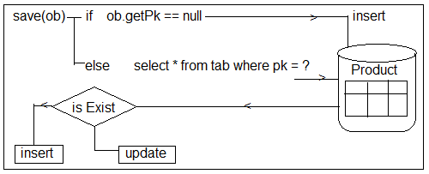

## #12. Folder Structure of Spring Boot Data JPA with Embedded DB H2 (Basic Operations):--

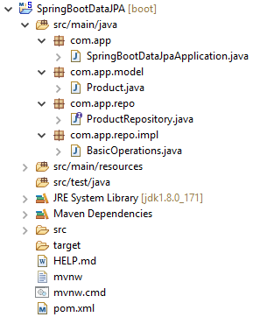

**Setup :- Create Project with dependencies H2, JPA, WEB > Finish pom.xml:--**

<!-- spring-boot-starter-data-jpa -->

<dependency>

<groupId>org.springframework.boot</groupId>

<artifactId>spring-boot-starter-data-jpa</artifactId>

</dependency>

<!-- H2 Database -->

<dependency>

<groupId>com.h2database</groupId>

<artifactId>h2</artifactId>

<scope>runtime</scope>

</dependency>

<!-- spring-boot-starter-web -->

<dependency>

<groupId>org.springframework.boot</groupId>

<artifactId>spring-boot-starter-web</artifactId>

</dependency>

## Step#1:- Add in application.properties:--

server.port=2019 spring.jpa.show-sql=true spring.h2.console.enabled=true spring.h2.console.path=/h2

## Step#2:- Define model class (Product.java):--

package com.app.model; import javax.persistence.Entity;

import javax.persistence.GeneratedValue; import javax.persistence.Id;

@Entity //Mandatory public class Product {

@Id //Mandatory @GeneratedValue private Integer prodId; private String prodName; private double prodCost; private String prodColor;

//super constructor public Product() {

super();

}

//Id (PK) based constructor public Product(Integer prodId) {

super();

this.prodId = prodId;

}

//Parameterized constructor without Id(PK)

public Product(String prodName, double prodCost, String prodColor) { super();

this.prodName = prodName; this.prodCost = prodCost;

this.prodColor = prodColor;

}

//Parameterized Constructor with Id (PK)

public Product(Integer prodId, String prodName, double prodCost, String prodColor)

{

super();

this.prodId = prodId; this.prodName = prodName; this.prodCost = prodCost; this.prodColor = prodColor;

}

//setters & getters method public Integer getProdId() { return prodId;

}

public void setProdId(Integer prodId) { this.prodId = prodId;

}

public String getProdName() { return prodName;

}

public void setProdName(String prodName) { this.prodName = prodName;

}

public double getProdCost() { return prodCost;

}

public void setProdCost(double prodCost) { this.prodCost = prodCost;

}

public String getProdColor() { return prodColor;

}

public void setProdColor(String prodColor) { this.prodColor = prodColor;

}

@Override

public String toString() {

return "Product [prodId=" + prodId + ", prodName=" + prodName + ", prodCost=" + prodCost + ", prodColor="+ prodColor + "]";

}

}

## Step#3:- Write Repository Interface (ProductRepository.java):--

package com.app.repo;

import org.springframework.data.jpa.repository.JpaRepository; import org.springframework.stereotype.Repository;

import com.app.model.Product;

@Repository //Optional

public interface ProductRepository extends JpaRepository<Product, Integer>

{ }

## Step#4:- CommandLine Runner for testing (BasicOperations.java):--

package com.app.repo.impl; import java.util.Optional;

import org.springframework.beans.factory.annotation.Autowired; import org.springframework.boot.CommandLineRunner;

import org.springframework.stereotype.Component; import com.app.model.Product;

import com.app.repo.ProductRepository;

@Component

public class BasicOperations implements CommandLineRunner{

@Autowired

private ProductRepository repo;

@Override

public void run(String... args) throws Exception {

/*1.*****************Save*******************/

//1. Method

repo.save(new Product("PEN", 6.8, "BLUE"));

repo.save(new Product("PENCIAL", 5.8, "RED")); repo.save(new Product("MOBILE", 5000.8, "BLACK")); repo.save(new Product("LAPTOP", 2000.8, "GRAY"));

/*2.*****************Find*******************/

//2.1 method.

Optional<Product> p = repo.findById(3); if(p.isPresent())

{

System.out.println(p.get());

} else {

System.out.println("No Data found");

}

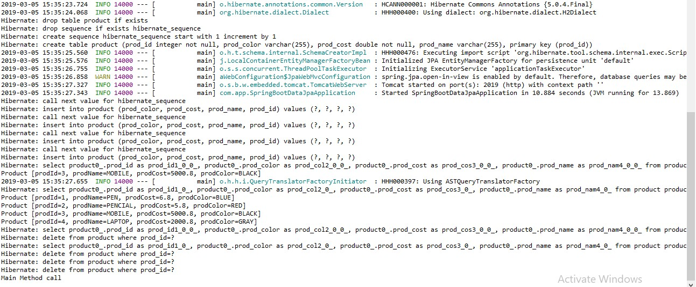

}

## Output:--

//2.2 Method. repo.findAll().forEach((System.out::println));

/*3. *****************Delete****************/

//3.1 Delete by specific Id repo.deleteById(3);

//3.2 Delete all Rows one by one in (Sequence order) repo.deleteAll(); //Multiple Query fired No of record = no of Query

//3.3 Delete all rows in Batch (Single Query fired) repo.deleteAllInBatch();

}

## Method Descriptions:--

**1>save (obj) :--** Behaves like save or update, If PK exist in DB table then “UPDATE” else “INSERT”.

**2>findById(ID): Optional<T> :--** It will return one row as one Object based on Primary key in Optional <T> format.

=>use methods isPresent() to check record is exist or not? If exist use method get() : T to read object.

**3>finadAll () :--** It returns Collection of Objects (=no Of rows in DB Table)

=>In simple select * from tableName; **4>deleteById(ID) :--** To delete one Row based on PK. **5>deleteAll() :--** To delete all Rows [One by one row]

**6>deleteAllInBatch () :--** To delete All rows at a time ex: delete from <tableName>

=>H2 is an Embedded database provided by SpringBoot which uses “hbm2ddl.auto=create-drop”, which means create table when server/app starts and drop all tables when server/app stopped.

=>H2 console works only if use WebApp and default path is : /h2-console, default port : 8080

**How to Show Data in H2 DataBase:-- Step#1:-** Execute Program:--

**Step#2:-** Type Url in Browser (http://localhost:2019/h2)

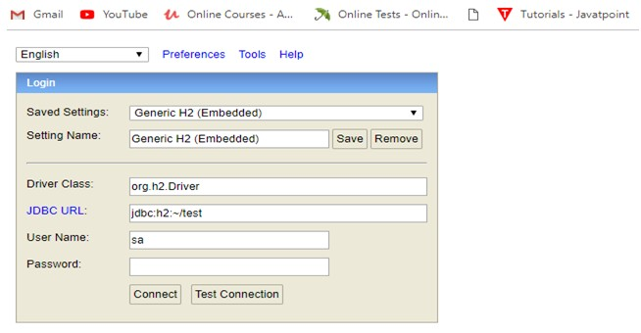

=>Click on connect.

## Step #3:-

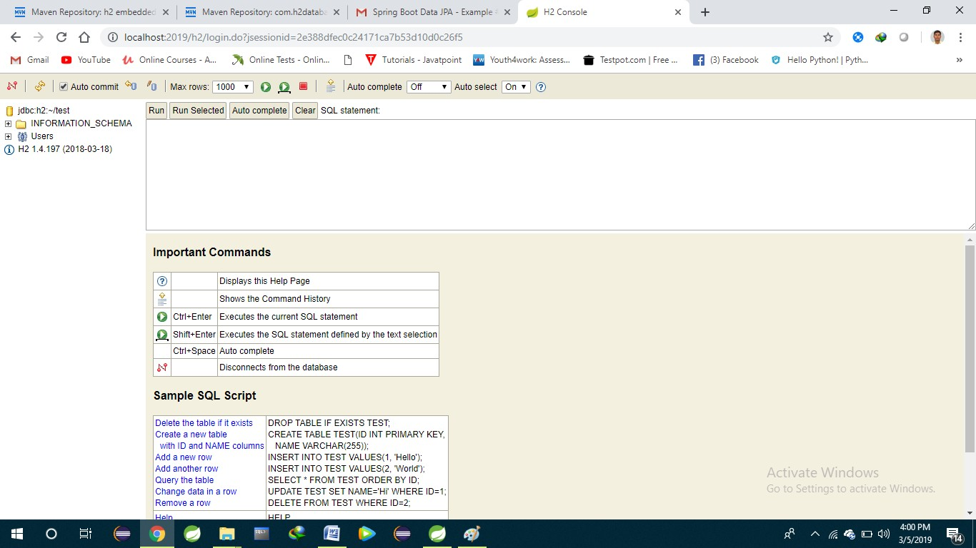

**2.2 Query Method in Spring Boot Data:--**

=>Spring Data generates a query based on method written in Repository by Programmer.

## Types of Query Methods (3):--

1>findBy

2>@Query (manual Query) 3>Special Parameters/ReturnTypes

=>These are used to specify our columns (Projections) and rows (restrictions) details.

**1>findBy :--** It will generate select query based on abstract method given by programmer. We can provide columns and rows details.

=>It will be converted to equal SQL query based on Database at runtime.

Syntax:--

RT findBy (Parameters …);

Here, RT = ReturnType, ex: List<T>, T, Object, Page<T>, Slice<T>, Object[], Specific Projection etc.

|  |  |  |  |  |
| --- | --- | --- | --- | --- |
| **[NareshIT, Hyd]**  **Spring Boot Data JPA findBy methods (where clause):--** | | | |  |
|  | **Keyword** | **Sample** | **JPQL snippet** |  |
| **And** | findByLastnameAndFirstname | … where x.lastname = ?1 and  x.firstname = ?2 |  |
|  | **Or** | findByLastnameOrFirstname | … where x.lastname = ?1 or  x.firstname = ?2 |  |
|  | **Is,Equals** | findByFirstname,findByFirstnameIs,  findByFirstnameEquals | … where x.firstname = ?1 |  |
|  | **Between** | findByStartDateBetween | … where x.startDate  between ?1 and ?2 |  |
|  | **LessThan** | findByAgeLessThan | … where x.age < ?1 |  |
|  | **LessThanEqual** | findByAgeLessThanEqual | … where x.age <= ?1 |  |
|  | **GreaterThan** | findByAgeGreaterThan | … where x.age > ?1 |  |
|  | **GreaterThanEqual** | findByAgeGreaterThanEqual | … where x.age >= ?1 |  |
|  | **After** | findByStartDateAfter | … where x.startDate > ?1 |  |
|  | **Before** | findByStartDateBefore | … where x.startDate < ?1 |  |
|  | **IsNull** | findByAgeIsNull | … where x.age is null |  |
|  | **IsNotNull,NotNull** | findByAge(Is)NotNull | … where x.age not null |  |
|  | **Like** | findByFirstnameLike | … where x.firstname like ?1 |  |
|  | **NotLike** | findByFirstnameNotLike | … where x.firstname not like ? | 1 |
|  | **StartingWith** | findByFirstnameStartingWith | … where x.firstname like ?1 (parameter bound with  appended %) |  |
|  | **EndingWith** | findByFirstnameEndingWith | … where x.firstname like ?1 (parameter bound with  preended %) |  |
|  | **Containing** | findByFirstnameContaining | … where x.firstname like ?1 (parameter bound wrapped  in %) |  |
|  | **OrderBy** | findByAgeOrderByLastnameDesc | … where x.age = ?1 order by  x.lastname desc |  |
|  | **Not** | findByLastnameNot | … where x.lastname <> ?1 |  |
|  | **In** | findByAgeIn(Collection<Age> ages) | … where x.age in ?1 |  |
|  | **NotIn** | findByAgeNotIn(Collection<Age>  ages) | … where x.age not in ?1 |  |
|  | **True**  **Naresh IT, Hyderaba** | findByActiveTrue()  **d P: 040-2374 6666,9000994007 /0** | … where x.active = true  **8] Page 80** |  |

**False** findByActiveFalse() … where x.active = false

… where UPPER(x.firstame) =

**IgnoreCase** findByFirstnameIgnoreCase UPPER(?1)

## LB Connect using Spring Data JPA

## Folder Structure:--

## 

**1>Starter class LBConnectApplication.java:--**

@SpringBootApplication

**public** **class** LbconnectApplication {

**public** **static** **void** main(String[] args) {

SpringApplication.*run*(LbconnectApplication.**class**, args);

}

}

**2>Model class Borrower.java,Lender.java,etc.**

## 3>Repository Interface (BorrowerRepository.java):--

=>Add below methods in Repository package com.app.repo;

import java.util.Collection;

import java.util.List;

import org.springframework.data.jpa.repository.JpaRepository; import org.springframework.stereotype.Repository;

import com.app.model.Product;

@Repository

public interface BorrowerRepository extends CRUDRepository<Borrower, Integer> {

}

**Service classes:**

Borrower Service.java

Lender Service.java

**Controller classes:**

Borrower Cotroller.java

LenderController.java

**Typical Application flow:**

Borrower Controller🡪Borrower Service🡪Borrower Repository🡪(MySQL Data(Borrower->Borrower table)

Connection will be created automatically using pom.xml in any spring-boot application.

# CHAPTER#3 MONGODB

1. **Introduction:--**

Spring boot supports working with NoSQL database Ex:- MongoDB.

=>MongoDB is a simple and open-source **document** database and leading NoSQL database and lightweight Database which stores data in JSON format.

=>JSON (Java Script Object Notation) it is object in java script language, but used in all programming, web services & DBs… etc.

=>Compare to programming object, XML or other Data formats JSON is light weight.

=>JSON format is : {“key” : value,….}.

=>JACKSON is a converter API used to convert java object <=> JSON. Another example for converter is GSON.

|  |  |
| --- | --- |
| **Java** | **Java Script** |
| int a =10;  Spring b = “Hi”; | var a = 10;  var b = “Hi”; |
| Employee e = new Employee(); e.setEmpId(10);  e.setEmpName(“A”); e.setEmpSal(3.5);  //Java Notation | var = {  “empId” : 10,  “empName” : “A”, “empSal” : 3.2  } |

**Download and Install MongoDB (NoSQL):-- Step#1:-** Goto MongoDB Download Center.

<https://www.mongodb.com/download-center/community>

**Step#2:-** Choose “Server” option and select details OS, Version and package (MSI) then click on download.

Details:

Version : 3.6 or 3.4

Type : MSI (Do not use ZIP)

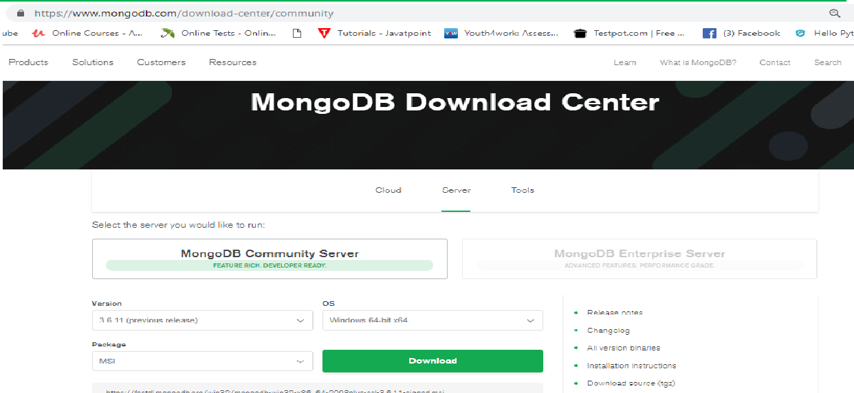**Step#3:-** Install DB in system (double click => next…=>finish).

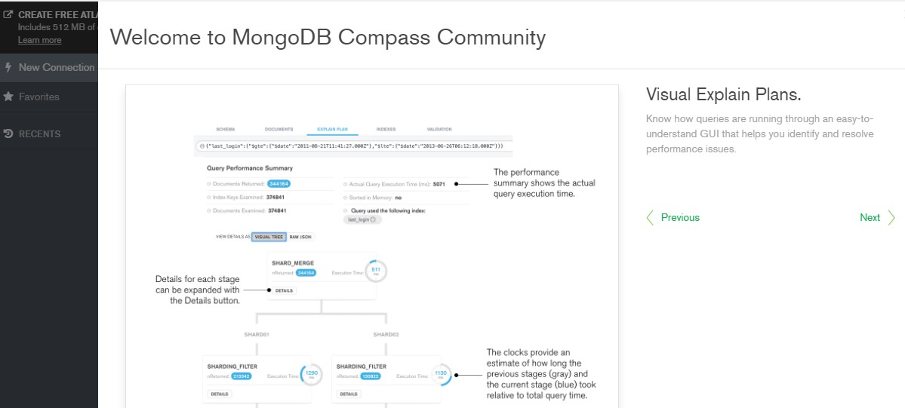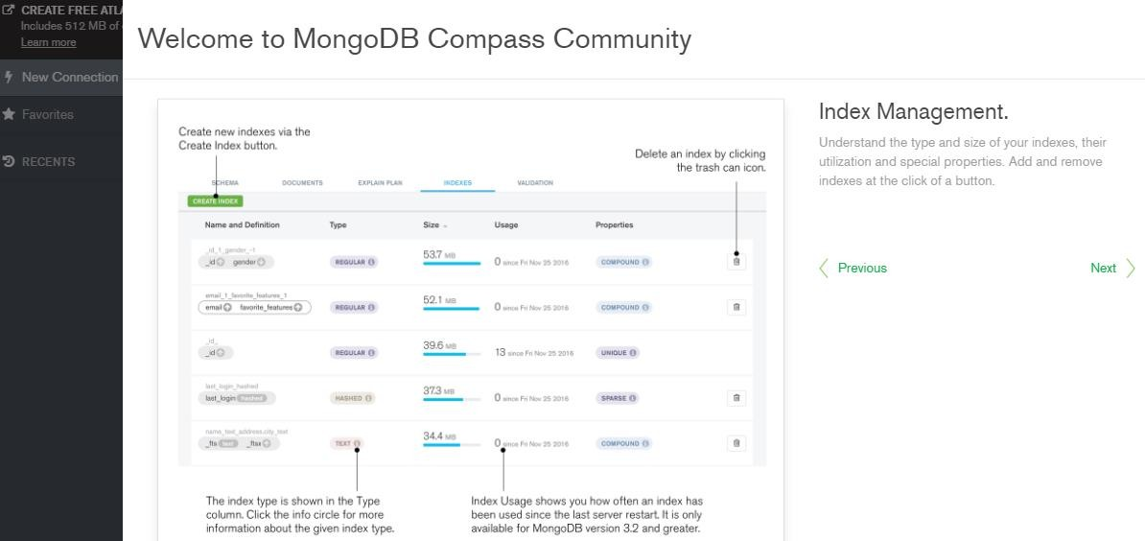=>While Installing Full (Complete) Type.

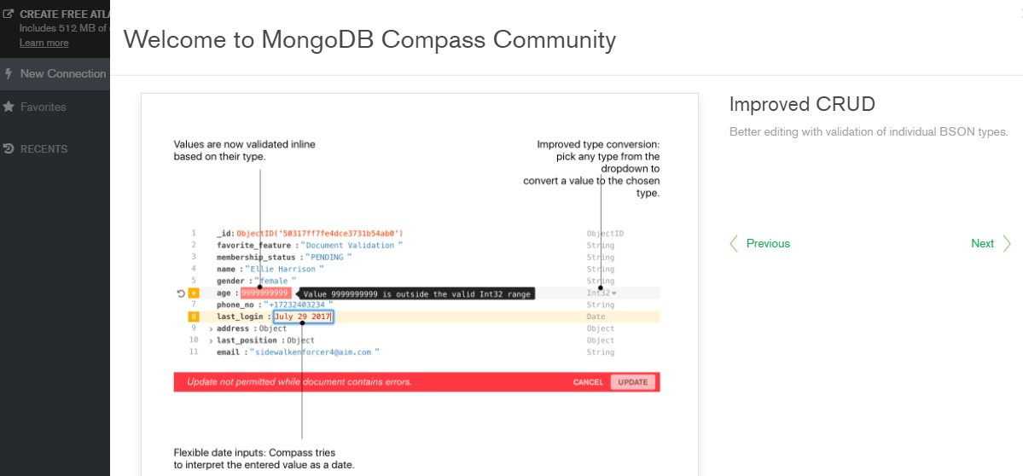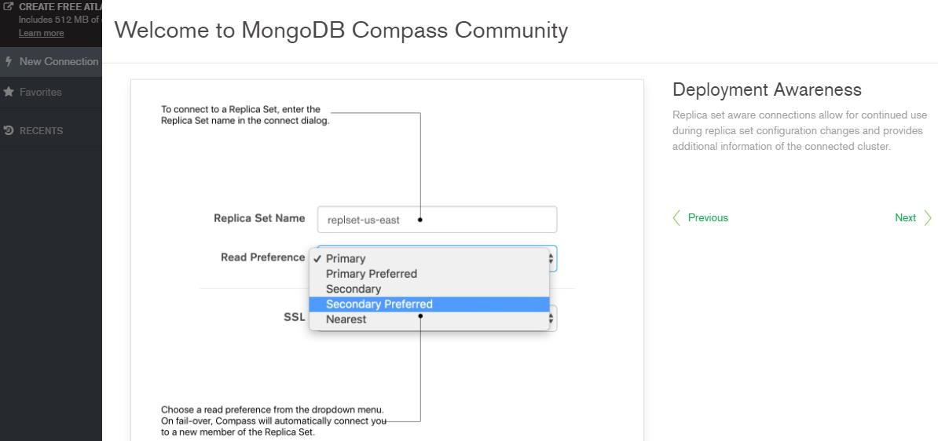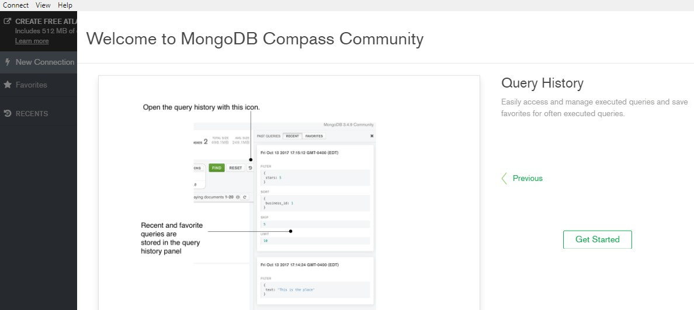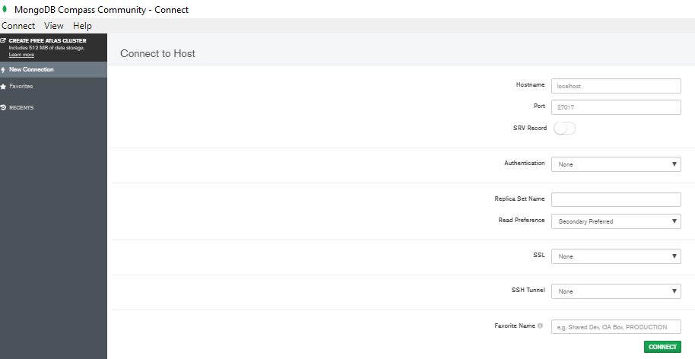

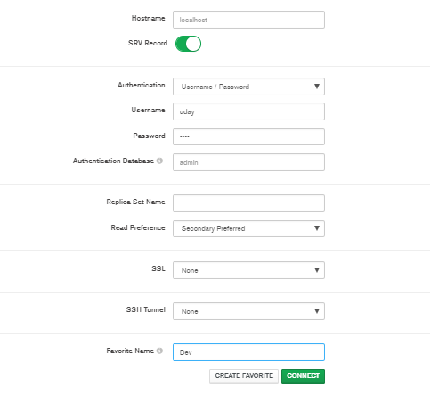

=>Open Notepad and Type below command

->mongod > save with .bat Ex:-- “mongo-server.bat”

->mongo > save with .bat Ex:--“mongo-client.bat”

**Step#4:-** Set Path to MongoDB Server

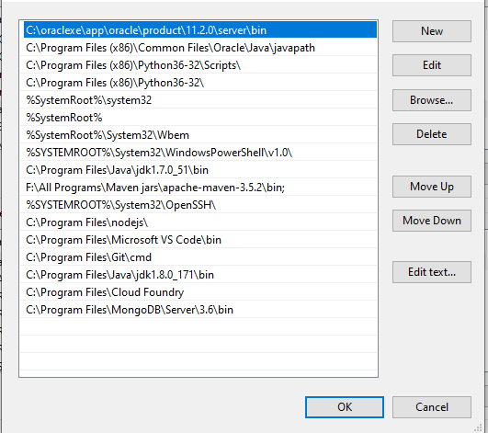

=>Copy location of MongoDB installed address till bin folder Ex:- C:\Program Files\MongoDB\Server\3.6\bin

=>Go to my Computer => Right click => Properties =>Advanced System Settings => Environment Variables => Chosse Path => Edit => Paste above location and symbol”;” => save =>finish.

**Step#5:-** Create service (server) folder in C:/ drive looks like “C:/data/db”. NOTE:-- Here folder name can be any things.

**Step#6:-** Start MongoDB server.

=>Open cmd prompt-1 => type mongod => press enter

**Ex:-** C:\Program Files\MongoDB\Server\3.6\bin>mongod

** To stop => press CTRL+C => Press y => enter

**Step#7:-** Start MongoDB Client

=>Open cmd prompt-2 =>type mongo => press Enter

**Ex:-** C:\Program Files\MongoDB\Server\3.6\bin>mongo

** It will start client.

## MongoDB commands:--

* show dbs / show databases => View All Databases.
* use sathya => Get into one DB (sathya)
* show collections => View All collections in DB
* db.book.insert ({"bcode" : "JAVA" , "bauth" : "ABC" , "bcost" : 3.3});

=>To insert one JSON row into Collection.

* db.<collectionName>.insert({“key”: val,….})
* db.book.find() [or] db.book.find.pretty(); Or
* db.book.find({“bcode”:”JAVA”})

=>To get JSON rows from collection.

=>Delete one Collection object

* db.book.remove({"bookCode":"JAVA"})

**More Commands goto <https://docs.mongodb.com/manual/reference/command/>

=>Here Tables are called **Collections**. Rows are called as **JSON objects**.

=>MongoDB holds data in JSON format created from java object.

i.e one Java Object <=>One JSON object.

=>ORM concepts says

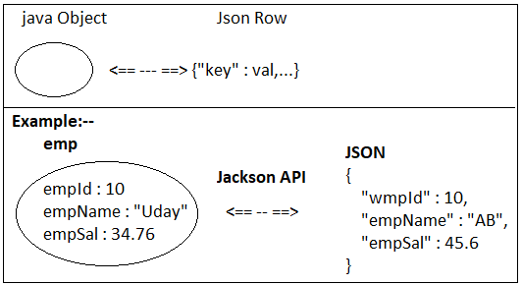

* 1. One class = one table.
  2. One variable = one column.
  3. One Object = one row.

=>But, MongoDB follows (NoSQL concepts. It contains Collections (behaves like tables, but not).

=>Collection holds data in JSON format.

1. One class = One collection.
2. One Object = one JSON Row.

=>Every class must be called as **Document** which can have generated ID (UUID type).

## ORM (SQL):--

Class Table (Model) (DB)

Object <== -- ==> Row

## (NoSQL):--

Class Collection (Document) (DB)

Object <== -- ==> JSON Rows

=>To work with MongoDB using spring boot we need to add its starter looks like.

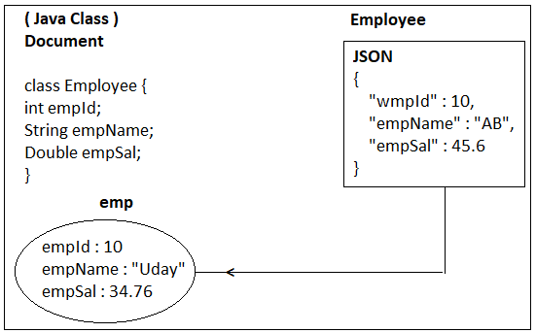

<dependency>

<groupId>ord.springframework.boot</gropId>

<artifactId>spring-boot-starter-data-mangodb</artifactId>

</dependency>

=>We can work with Installed MongoDB or embedded MongoDB. In case of embedded use dependency in pom.xml (remove <scope>test </scope>).

<dependency>

<groupId>de.flapdoodle.embed</groupId>

<artifactId>de.flapdoodle.embed.mongo</artifactId>

</dependency>

=>Boot also supports Embedded MongoDB for every coding and Testing Process.

=>Embedded MongoDB can be used in Dev, Test, Uat, but not in Production Environment.

## Design#1:- Spring Boot MongoDB Repository Levels:--

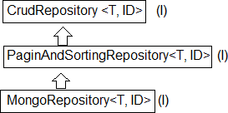

**Design#2:- Spring Boot MongoDB Coding files:--**

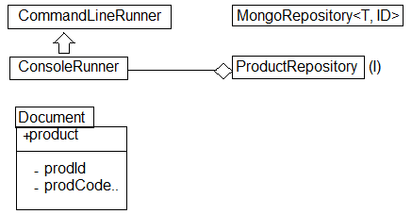

**2. Spring Boot External MongoDB Setup and code:--**

=>To work External MongoDB using Spring Boot we need to provide only details of DB in application properties of yml files like.

=>Default port no of MongoDB server is **27017**.

spring.data.mongodb.host=localhost spring.data.mongodb.port=27017 spring.data.mongodb.database=test_db

=>By default MongoDB comes with NoSecure/NoAuth Setup, we can provide authentication details (username, password for login and logout). In that case we must provide extra keys like.

spring.data.mongodb.username=sa spring.data.mongodb.password=sa

## application.yml :--

spring:

application:

name: loan-history #service name

eureka:

instance:

leaseRenewalIntervalInSeconds: 1

leaseExpirationDurationInSeconds: 2

client:

serviceUrl:

defaultZone: http://192.168.100.8:8761/eureka/

lease:

duration: 5

**Step#1:-** Create one Spring Boot Starter project NAME : loanhistory

Dependency : Spring Data MongoDB

## MongoDB Dependency:--

<dependency>

<groupId>org.springframework.boot</groupId>

<artifactId>spring-boot-starter-data-mongodb</artifactId>

</dependency>

## 17. Folder Structure of External MongoDB:--

## 

**pom.xml:--**

<?xml version=*"1.0"* encoding=*"UTF-8"*?>

<project xmlns=*"*[*http://maven.apache.org/POM/4.0.0*](http://maven.apache.org/POM/4.0.0)*"* xmlns:xsi=*"*[*http://www.w3.org/2001/XMLSchema-instance*](http://www.w3.org/2001/XMLSchema-instance)*"*

xsi:schemaLocation=*"*[*http://maven.apache.org/POM/4.0.0*](http://maven.apache.org/POM/4.0.0)[*http://maven.apache.org/xsd/maven-4.0.0.xsd*](http://maven.apache.org/xsd/maven-4.0.0.xsd)*"*>

<modelVersion>4.0.0</modelVersion>

<parent>

<groupId>org.springframework.boot</groupId>

<artifactId>spring-boot-starter-parent</artifactId>

<version>2.7.8</version>

<relativePath/> <!-- lookup parent from repository -->

</parent>

<groupId>com.colt.loanhistory</groupId>

<artifactId>loanhistory</artifactId>

<version>0.0.1-SNAPSHOT</version>

<name>loanhistory</name>

<description>loanhistory Application</description>

<properties>

<java.version>1.8</java.version>

<spring-cloud.version>2021.0.5</spring-cloud.version>

</properties>

<dependencies>

<dependency>

<groupId>org.springframework.boot</groupId>

<artifactId>spring-boot-starter-data-mongodb</artifactId>

</dependency>

<dependency>

<groupId>org.springframework.boot</groupId>

<artifactId>spring-boot-starter-web</artifactId>

</dependency>

<dependency>

<groupId>org.springframework.boot</groupId>

<artifactId>spring-boot-starter-test</artifactId>

<scope>test</scope>

</dependency>

<dependency>

<groupId>org.springframework.cloud</groupId>

<artifactId>spring-boot-starter-netflix-eureka-client</artifactId>

</dependency>

</dependencies>

<dependencyManagement>

<dependencies>

<dependency>

<groupId>org.springframework.cloud</groupId>

<artifactId>spring-cloud-dependencies</artifactId>

<version>${spring-cloud.version}</version>

<type>pom</type>

<scope>import</scope>

</dependency>

</dependencies>

</dependencyManagement>

<build>

<plugins>

<plugin>

<groupId>org.springframework.boot</groupId>

<artifactId>spring-boot-maven-plugin</artifactId>

</plugin>

</plugins>

</build>

</project>

**Step#2:-** Open application.properties (.yml) and provide mongoDB host, port, database etc... details.

**application.properties:--**

server.port=8083

spring.data.mongodb.host=localhost

spring.data.mongodb.port=27017 spring.data.mongodb.database=test_db

**Step#3:-** Define, repo, Runner (same as before example).

**package** com.colt.loanhistory.loanhistory.repository;

**import** java.util.List;

**import** org.springframework.data.mongodb.repository.MongoRepository;

**import** org.springframework.stereotype.Repository;

**import** com.colt.loanhistory.loanhistory.entities.Payments;

@Repository

**public interface** PaymentsRepository **extends** MongoRepository <Payments, String>{

**public** List<Payments> findByLoanId(**int** loanId);

**public** Payments save(Payments payments);

}

## Step#4:- Define one Runner class.

package com.colt.loanhistory.loanhistory.controller;

import java.util.List;

import org.springframework.beans.factory.annotation.Autowired;

import org.springframework.web.bind.annotation.GetMapping;

import org.springframework.web.bind.annotation.RequestBody;

import org.springframework.web.bind.annotation.RequestMapping;

import org.springframework.web.bind.annotation.RequestMethod;

import org.springframework.web.bind.annotation.RequestParam;

import org.springframework.web.bind.annotation.RestController;

import com.colt.loanhistory.loanhistory.entities.Payments;

import com.colt.loanhistory.loanhistory.repository.PaymentsRepository;

@RestController

public class LoanHistoryController {

@Autowired

PaymentsRepository paymentsRepository;

@GetMapping("/Hi")

public String getDetails() {

return "Hello LH";

}

@RequestMapping(value = "/create", method = RequestMethod.POST)

public Payments saveCustomer(@RequestBody Payments customer) {

customer = paymentsRepository.save(customer);

return customer;

}

@RequestMapping(value = "/read", method = RequestMethod.GET)

public List<Payments> readCustomer() {

return paymentsRepository.findAll();

}

@RequestMapping(value = "/get", method = RequestMethod.GET)

public List<Payments> modifyByID(@RequestParam int loanId) {

return paymentsRepository.findByLoanId(loanId);

}

}

**Execution Process:--** Goto MongoDB install directory till bin folder and open two cmd prompt.

=>Open cmd-1 and type > mongod (to start server)

=>Open cmd-2 and type > mongo (to open and work on DB)

=>Run starter class and go to mongo client to see output.

## Console Output:--

1. **Working with Multiple values of JSON in MongoDB:--**

=>In general JSON key=value combination indicates primitive Data format. Ex:-- {“empId” : 25, “empName”: ”Uday”}

=>To store multiple values we can use collection type.

* 1. **List/Set/Array :--**

=>In case of java these are different but coming to JSON format holds as group of elements. Format is given as : [“value”, “value”].

## #18. Folder Structure of Collection (List/Set/Array) Data in MongoDB:--

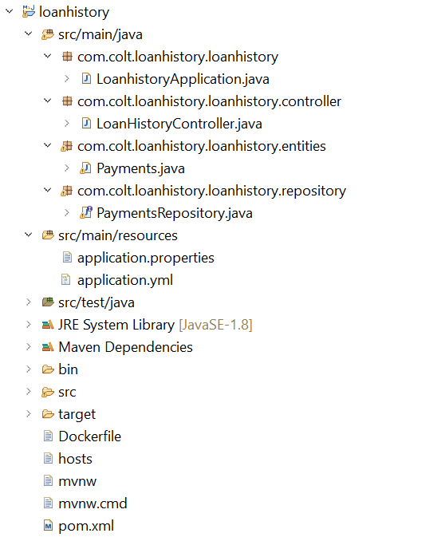**application.properties:--**

server.port=8083

spring.data.mongodb.host=localhost

spring.data.mongodb.port=27017 spring.data.mongodb.database=test_db

1. **Document class:-- package** com.app.document;

**package** com.colt.loanhistory.loanhistory.entities;

**import** java.time.LocalDate;

**import** com.fasterxml.jackson.annotation.JsonProperty;

**public class** Payments {

**private** int paymentId;

**private** int loanId;

**private** LocalDate paymentDate;

**private** long UTR;

@JsonProperty("emi")

**private** int amount;

**public** int getPaymentId() {

return paymentId;

}

**public** void setPaymentId(int paymentId) {

this.paymentId = paymentId;

}

**public** int getLoanId() {

return loanId;

}

**public** void setLoanId(int loanId) {

this.loanId = loanId;

}

**public** LocalDate getPaymentDate() {

return paymentDate;

}

**public** void setPaymentDate(LocalDate paymentDate) {

this.paymentDate = paymentDate;

}

**public** long getUTR() {

return UTR;

}

**public** void setUTR(long uTR) {

UTR = uTR;

}

**public** int getAmount() {

return amount;

}

**public** void setAmount(int amount) {

this.amount = amount;

}

**public** Payments(int paymentId, int loanId, LocalDate paymentDate, long UTR, int amount) {

super();

this.paymentId = paymentId;

this.loanId = loanId;

this.paymentDate = paymentDate;

UTR = UTR;

this.amount = amount;

}

}

1. **Repository:--**

**package** com.colt.loanhistory.loanhistory.repository;

**import** java.util.List;

**import** org.springframework.data.mongodb.repository.MongoRepository;

**import** org.springframework.stereotype.Repository;

**import** com.colt.loanhistory.loanhistory.entities.Payments;

@Repository

**public interface** PaymentsRepository **extends** MongoRepository<Payments, String>{

**public** List<Payments> findByLoanId(int loanId);

**public** Payments save(Payments payments);

}